Tencent Cloud‘s First Generation Star Lake GPU Server with Industry Firsts

Tencent Cloud released the first generation Star Lake GPU server and the next-generation Star Lake dual-socket server, with the latter being the first dual-socket server in China to be built on the 3rd Gen Intel® Xeon® Scalable Processors (Ice Lake).

At the “Next-generation Software-Hardware Integrated Cloud Computing Infrastructure” sub-forum of 2020 Techo Park held by Tencent in December 2020, Qick Liu, General Manager of Tencent Cloud Server and Supply Chain, said that as cloud computing loads increase, it is becoming more challenging for traditional servers to address requirements for super-large scale, diverse demands, cost-effectiveness, safety and reliability, and software-hardware integration in cloud computing data centers. Through constant development of software-hardware integration, Tencent Cloud is able to provide higher-performance and more cost-effective experiences for developers based on their diverse demands.

The first generation Star Lake GPU server by Tencent Cloud

Based on a deep understanding of business demands, Tencent Cloud is rolling out its first generation Star Lake GPU server.
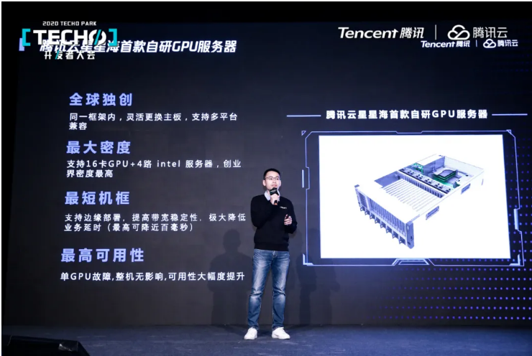
The first generation Star Lake GPU server

In cloud gaming scenarios, as customers are highly sensitive to single-GPU TCO and single-user cost, cost reduction has become a pressing issue. However, existing GPU server chassis are too long to cope with delayed edge deployment. When the demands are not responded to, the collapse of single GPU will lead to machine downtime.

To address similar issues and business demands, the first generation Star Lake GPU server has made bold innovations and breakthroughs in performance, energy efficiency, safety features and reliability. In terms of design, the product is the first in the world to allow for mainboard replacement in the same framework, supporting multiple platforms and bringing a competitive edge to businesses when facing GPUs choices; in the meantime, the product supports 16-GPU + 4-socket Inter® servers in light of the low demand on PCIe bandwidth of businesses, achieving the highest density and drastically reducing single-GPU TCO. In terms of innovation, the product provides the shortest chassis to support edge deployment and improve bandwidth stability, drastically reducing delay (by up to 100ms); in terms of applicability, the RAS features and PCIe Hot-plug features of the product help prevent single GPU breakdown from affecting machine running, significantly improving applicability.

The next-generation Star Lake dual-socket server

As AI, 5G, IoV and IoT technologies are being deployed in large scales, businesses are becoming more demanding on computing power and storage. The next-generation Star Lake dual-socket server, as the first such server in China to be built on the 3rd Gen Intel® Xeon® Scalable Processors (Ice Lake), will provide users with higher memory bandwidth, higher I/O throughput and more powerful instance performance, and help boost built-in AI acceleration based on Intel® DL Boost.

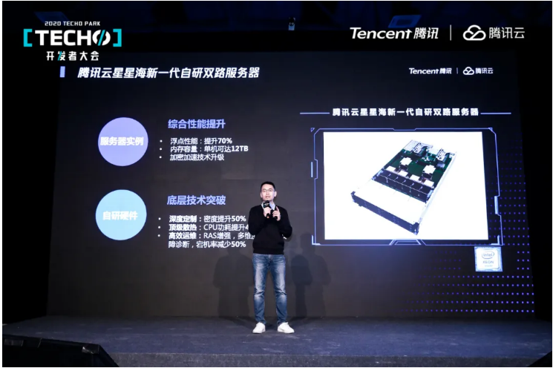
The next-generation Star Lake dual-socket server

The next-generation Star Lake dual-socket server is built on 3rd Gen Intel® Xeon® Scalable Processors. It adopts Intel’s 10nm process and enables various sorts of business computing, including general computing, heterogeneous computing, bare metal, and high-performance computing. As shown by testing data, compared with dual-socket servers built on the 2nd Gen Intel® Xeon® Processors, the new server sees an improvement of 70% in floating-point performance, and supports up to 12TB memory of single socket, sufficient for businesses such as large databases.With in-depth optimization and customization of the next-generation Star Lake dual-socket server, the computing density is improved by 50%; with high-performance radiator and innovative independent wind channel design, the CPU efficiency is improved by 45%; the reinforced reliability, availability and serviceability (RAS) technologies enable all-rounded error diagnosis and accurate positioning, reducing downtime by 50%.

To address cloud business demands, the next-generation Star Lake dual-socket server significantly empowers Tencent Cloud’s strategic matrix in cloud computing, providing users with higher computing performance and flexible deployment, and effectively reducing the overall cost of cloud services. With its hardware system architecture design and visionary research in fundamental technologies, the next-generation Star Lake dual-socket server is able to support the visionary architecture evolution in the next 3-5 years, bringing dividends of technological development in advance to early adopters of cloud-based development and deployment.

Intel Global Cloud Account Director Micheal Mi said, “Intel is dedicated to building a solid foundation for intelligent cloud based on its all-round ‘data-centric’ portfolio, powerful partner ecosystem and constant technological innovations. We will continue to work with Tencent to accelerate intelligent cloud computing and new infrastructures, and embrace the digital economy era.”

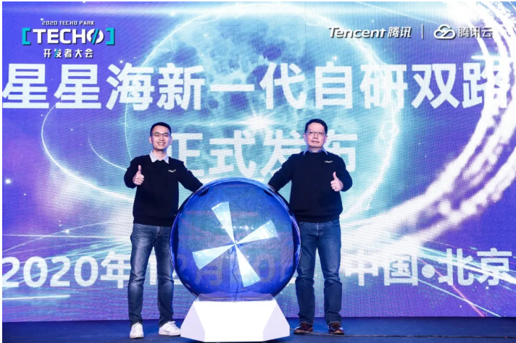
(Left: Qick Liu, General Manager for Tencent Cloud Server and Supply Chain; Right: Micheal Mi, Intel Global Cloud Account Director)

It is worth mentioning that the two servers are both developed by Star Lake Hardware Laboratory, the first hardware engineering laboratory of Tencent. It is focused on hardware system architecture design and visionary research in fundamental technologies. To date, the Lab has released various hardware products, including four servers and one intelligent Internet card, and has applied for over 20 patents in the computing, storage, network and other hardware product fields.

