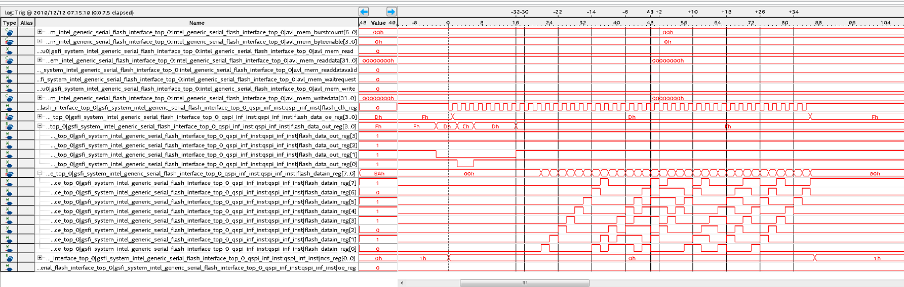
8 Cycles
Command
9Fh
0
9
1
1
A
B
0
2
Timing from device ID read using generic flash controller IP
1 Cycle
Dummy?
1 Cycle
19h is device ID

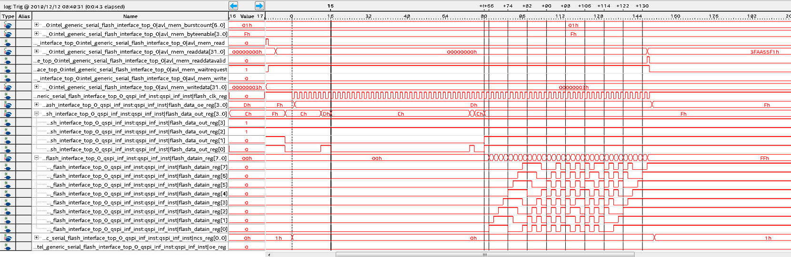
8 Cycles
Command
03h
32 Cycles
4 byte addr
Read from 4h
F
3
A
A
5
5
1
F
1 Cycle
Dummy?

Timing from read address 0x4h using generic flash controller IP. Read is 3FAA55F1h.

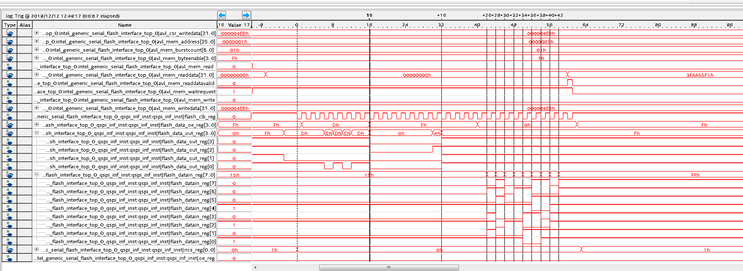
8 Cycles
Command
03h
8 Cycles
4 byte addr
Quad Read from 4h
4 Cycle
Dummy
F
3
A
A
5
5
1
F

Timing from extended quad input fast read address 0x4h using generic flash controller IP. Read is 3FAA55F1h.

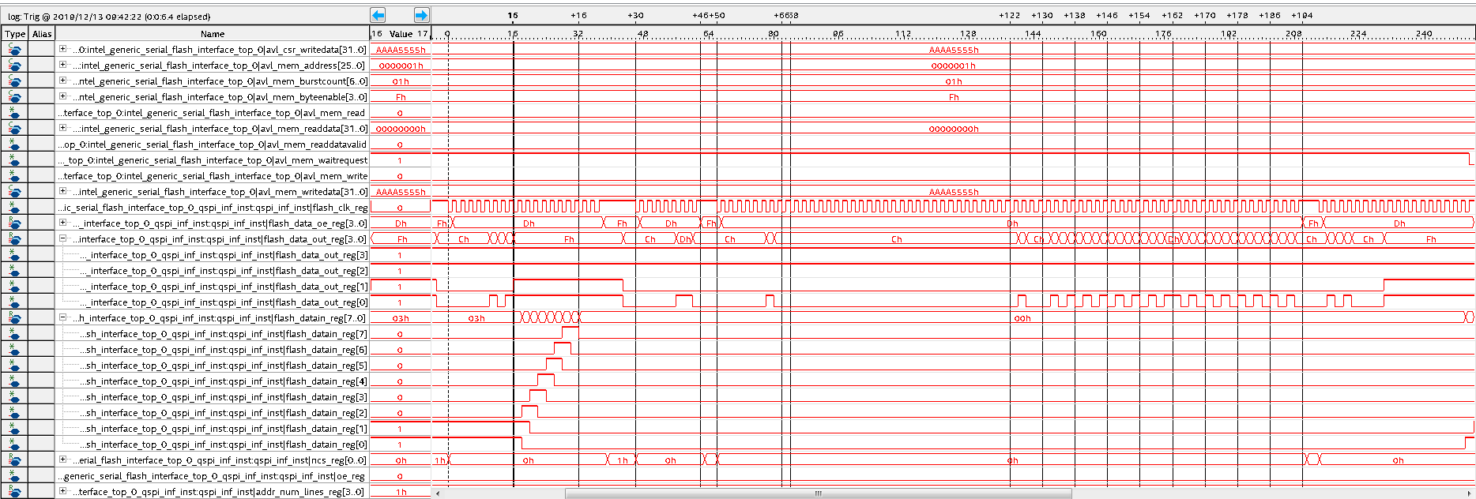
8 Cycles
Command
05h, read status
8 Cycles
Command
06h, write enable
8 Cycles
Command
02h, write bytes
32 Cycles
4 byte addr write to 4h
5
5
5
5
A
A
A
A
Addr Bits 3-0
4h

Timing from write bytes address 0x4h using generic flash controller IP. Read is AAAA5555h.

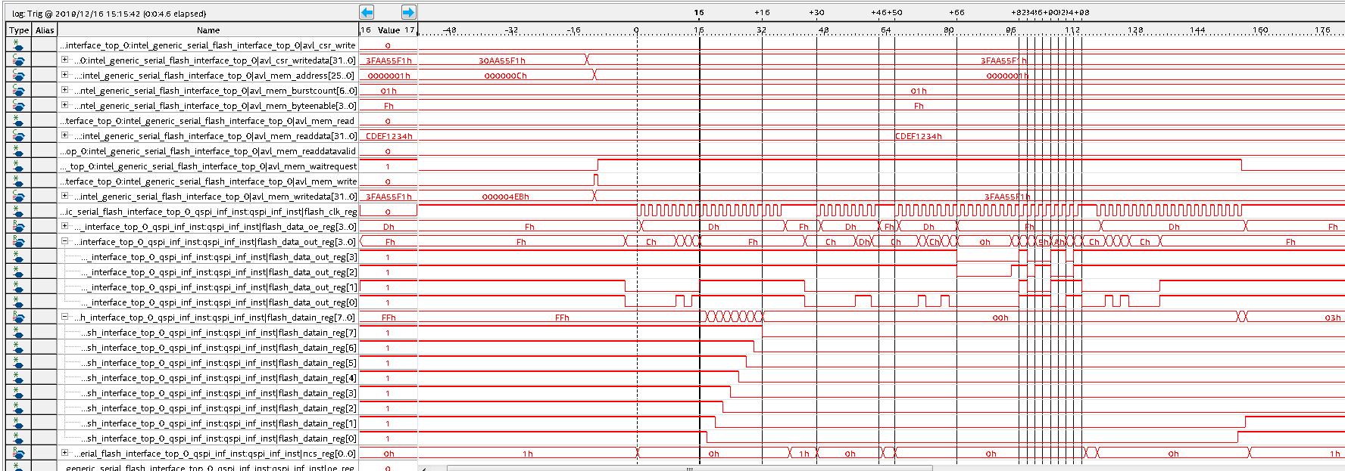
8 Cycles
Command
05h, read status
8 Cycles
Command
06h, write enable
Addr Bits 3-0
4h
8 Cycles
4 byte addr write to 4h
8 Cycles
Command
12h, quad write bytes
F
3
A
A
5
5
1
F

Timing from quad fast write address 0x4h using generic flash controller IP. Read is 3FAA55F1h.

