

University Workshop:
Introduction to Internal & External FPGA Memory Lab Manual
Tutorial

Copyright © 2019 Intel Corporation
All Rights Reserved
Revision: 001.1

Legal Information
©2018 Intel Corporation. All rights reserved. ALTERA, ARRIA, CYCLONE, HARDCOPY, INTEL, MAX, MEGACORE, NIOS, QUARTUS and STRATIX words and logos are trademarks of Intel Corporation and registered in the U.S. Patent and Trademark Office and in other countries. All other words and logos identified as trademarks or service marks are the property of their respective holders as described at www.altera.com/common/legal.html. Intel warrants performance of its semiconductor products to current specifications in accordance with Intel's standard warranty, but reserves the right to make changes to any products and services at any time without notice. Intel assumes no responsibility or liability arising out of the application or use of any information, product, or service described herein except as expressly agreed to in writing by Intel. Intel customers are advised to obtain the latest version of device specifications before relying on any published information and before placing orders for products or service
Revision History
Revision Number | Editor | Description | Revision Date
1 | Ramon Crespo | Initial External Release. | 03/05/2019
1.1 | Ramon Crespo | Improved Lab 2 Flow. Reduce the Material | 03/28/2019

Contents
Contents
About This Document 4
Intended Audience 4
Using this tutorial 4
Conventions and Symbols 4
Related Information 5
Utilizing FPGA Internal Memory Structures 6
FPGA Memory Types 6
Block Diagram 6
Building the system 7
Step 1.1: Download files 7
Step 1.2: Open project and review design 7
Step 1.3: Create an on-chip RAM 8
Step 1.4: ROM Lookup 10
Step 1.5: Simulate design 11
Step 1.6: Program Board 15
Step 1.7: Observe in Signal Tap 16
Design Flow for an External SDRAM 18
Utilizing the FPGA External Memory Interface IP 20
Block Diagram 20
Step 2.1: Install tutorial files 20
Step 2.2: Open project 21
Step 2.3: Setting up the Software 22
Step 2.4: Signal Tap SDRAM 24
Step 2.5: Switch to on-chip Design 28
Step 2.6: Signal Tap On-Chip Design 31
Step 2.7: Compare 32
Appendix 34
Step 2.9: Simulate with the Avalon Bus Functional Model 34
Step 2.8Modelsim and Compare 36

About This Document
This is the laboratory manual for the FPGA Memory Interface workshop. The laboratory provides a practical introduction to memory interfacing for Intel FPGA. This document takes the student through the process of configuring and assembling an on-chip dual port RAM, single port ROM, and external SDRAM.

Intended Audience
This material is ideally suited for EE/CS students familiar with Boolean combinational logic and sequential logic. Familiarity with Intel FPGA design tools are not necessary but nice to have.

Using this tutorial
For this tutorial is required to download, install and load Quartus Prime Lite design software to your laptop. Allow 40+ minutes for the installation process. No license is required.
- Visit http://fpgasoftware.intel.com/
- Select version 18.1 or higher and your PC's operating system. Make sure Edition "Lite" is selected.
- For the smallest/fastest download, unselect all, then only select "Quartus Prime (includes Nios II EDS)”, "MAX 10 device support" and Modelsim-Intel FPGA Edition.
- Click "Download Selected Files" and follow the prompts for installation.
Table 1 Document Organization
Section | Description
On Chip Memory Design Flow | A brief introduction to the design flow for applications that includes an on chip memory.
Utilizing FPGA Internal Memory Structures | A guided step by step to build simple On Chip memory interface with self-testing.
External Memory Design Flow | A brief introduction to the design flow for applications that includes external memory.
Utilizing FPGA EMIF | A guided step by step to test an external memory interface for functionality, and compare it to internal.

Conventions and Symbols
The following conventions are used in this document.
Table 2 Conventions and Symbols used in this Document
This type style | Indicates an element of syntax, reserved word, keyword, filename, computer output, or part of a program example. The text appears in lowercase unless uppercase is significant.
This type style | Indicates the exact characters you type as input. Also used to highlight the elements of a graphical user interface such as buttons and menu names.
This type style | Indicates a placeholder for an identifier, an expression, a string, a symbol, or a value. Substitute one of these items for the placeholder.
[ items ] | Indicates that the items enclosed in brackets are optional.
{ item | item } | Indicates to select only one of the items listed between braces. A vertical bar ( | ) separates the items.
... (ellipses) | Indicates that you can repeat the preceding item.

Related Information
- DE10-Lite User Manual
- Intel® Quartus® Prime Standard Edition Handbook Volume 1 - Design and Synthesis
- SignalTap II Embedded Logic Analyzer Basics
- Intel FPGA Youtube Channel

Utilizing FPGA Internal Memory Structures

FPGA Memory Types

Block Diagram
This is a simple base design that implements two on chip memories: dual port RAM, and a ROM. A dual port RAM indicates that the memory has two address ports. An address port can have a read port, a write port or both. In this configuration, we will use one port for reads, the other for writes, associated with each address port. These can also run with two different clocks as is often done with a FIFO (first-in first-out) memory.
The ROM is initialized with data that will dictate what goes on the offset signal to the adder, and the write enable (WEA) signal to the dual port RAM, creating a self-testing loop that verifies functionality of the interface. The up and down counters will tell the dual port RAM which address to read or write to at two different clock rates.

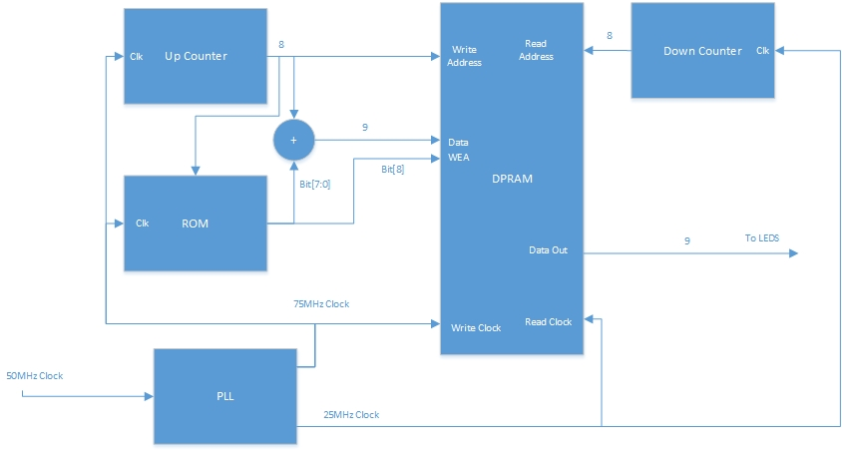
Figure 1: Internal Memory Interface

Building the system
The next steps take you through the process of configuring and connecting the required modules to assemble a fully integrated on chip memory interface that self-tests for functionality. The steps take you from assembly to the hardware validation of the design.

Step 1.1: Download files
You can download the lab files from this link: Download Lab_1_Onchip.qar to your computer. This tutorial expects that the destination folder of the project files is the root directory of your computer (C:\). If you are using a different location, make sure that you adjust all references to the project directory according.
Make sure that the destination path for does not include any whitespaces. If your path includes whitespaces, you will run into issues in the simulation section of this manual as the simulation tool is sensitive to white spaces in file and folder names.

Step 1.2: Open project and review design
Open Quartus lite, then click ‘File’ and select ‘Open Project…’
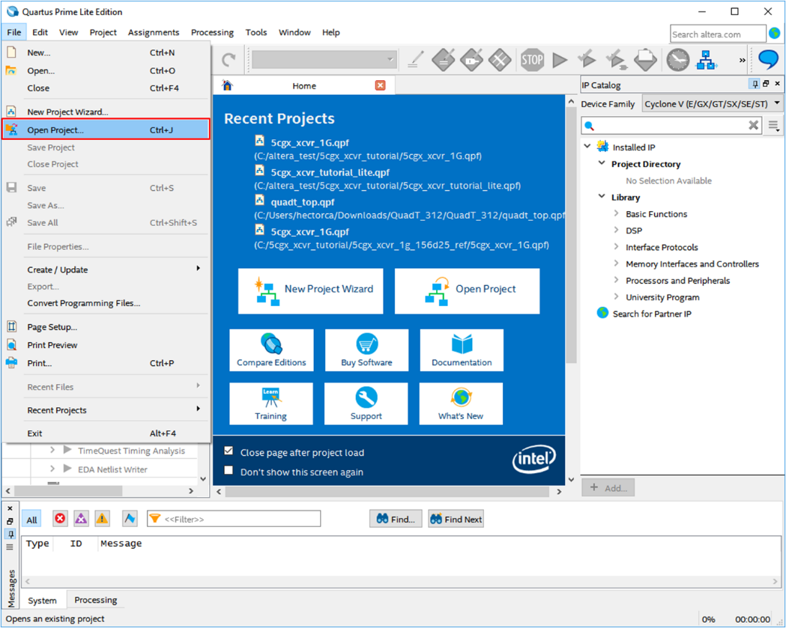
Figure 2: Opening a Quartus .qar

Navigate to the folder where the download went and select ‘Lab_1_onchip.qar’, then click ‘Open’ in an empty folder.
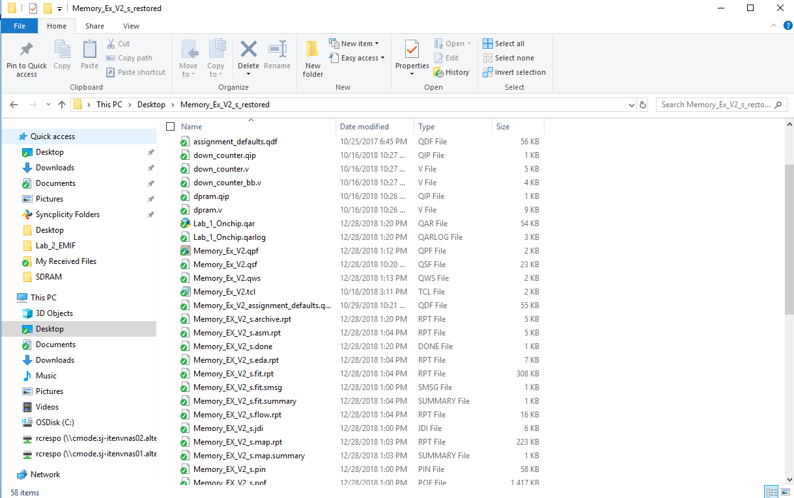
Figure 3: Selecting Memory Files

Step 1.3: Create an on-chip RAM
Go to IP Catalog and search for ‘On Chip’, double click on ‘RAM 2-PORT’
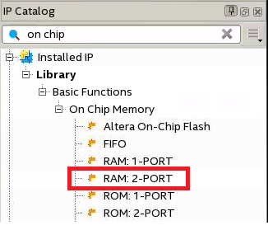
Figure 4: Selecting RAM IP

Name ‘dpram’ the new IP variation. Make sure that ‘Verilog’ is selected as the file type. Click ‘OK’ once you have finished.
Using a different naming convention for the IP will result in errors on the next steps of the tutorial.
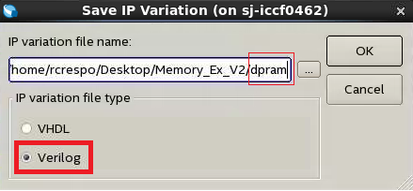
Figure 5: Naming RAM IP

MegaWizard Plug-In Manager will launch. To start with, set dual port use to “With one read port and one write port” and specify the memory size “As a number of words”.
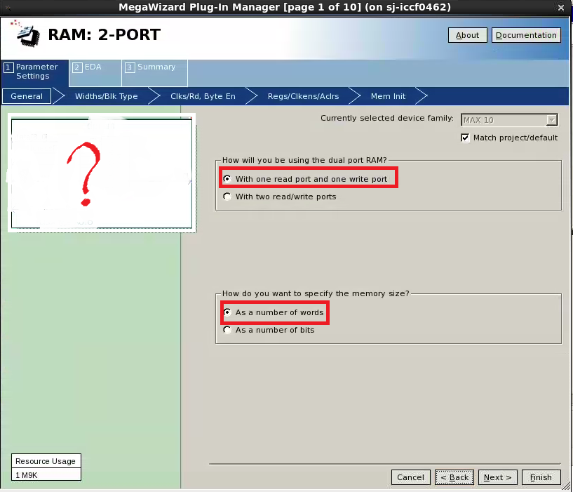
Figure 6: Selecting IP Initial Settings

Note the block diagram was removed from the previous image, that’s because you will specify the size for the specs we need to meet, which we will get into later. Click next and you’ll see some options.
From the original block diagram above, you know that the ‘data’ (data + WEA) size is 9 bits in width.

Quiz
What is the total number of ‘words’ that you should be able to store with the 8 bits? Select the correct option at the top of the Widths/Blk Type tab.
For Read/Write ports, select the data_a width to be 9 bits, matching the block diagram, click next. If you play around with the settings, you’ll see that the resource usage in the bottom left corner changes from 1 M9k to more as you demand more from the RAM IP, these are the principal FPGA memory blocks discussed in the lecture.
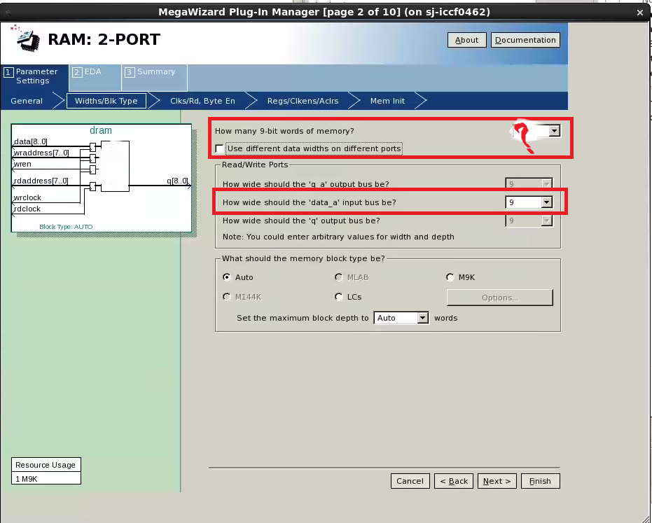
Figure 7: Selecting Proper RAM Settings

In the ‘Clks/Rd, Byte En’ tab select clocking method to be ‘Dual clock: use separate ‘read’ and ‘write’ clocks, click next. Next tab ‘Regs/Clkens/Aclrs’ under ports registered, deselect ‘Read output port(s) q’, we don’t need the output to be registered for this application, otherwise it would delay the path by one extra clock cycle in order to register it. Click Finish, if prompted again hit Finish, if printed to include .qip files hit yes.
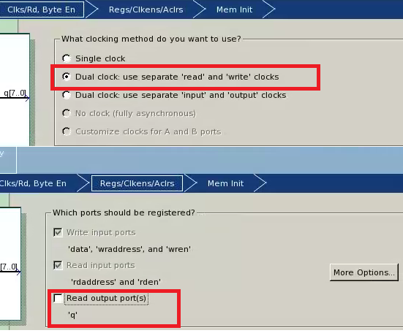
Figure 8: Ram Clock & Output Options

Step 1.4: ROM Lookup
Navigate to the memory initialization file we created for you, it’s called rom.mif in the project folder, open it up with a text editor, I’m using Notepad++. When you open it up, you’ll see it’s a very simple file, fill it up the specific address with the 9 bit information you need to prove yourself in simulation that the system works. The solution to the ROM space should be clear on the block below.
Addresses | Decimal | Hex | Function
0->63 | 322 | x142 | Writing 66 Decimal
64->126 | 66 | X42 | Not Writing 66 Decimal
128->191 | 323 | X143 | Writing 67 Decimal
192->255 | 0 | 0 | Testing for 0 case
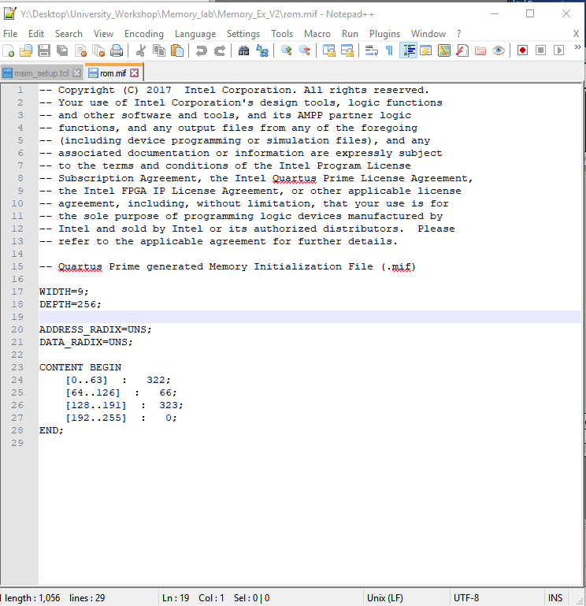

Figure 9: Configuring ROM and accompanying explanation
The reason our pattern is 322, 66, 323, and 0, is because numbers above 255 have the highest bit of the high (i.e. 101000010 is equivalent to 256 + 64 + 2 = 322 our first number) the highest bit represent the WE (write enable) signal, which we need to enable to test the dual port RAM fully (the other 8 bits representing the offset). Then we have 66 for control (WE off) then 323 to test for different offset, and 0 to test for no signal coming from the ROM.
Make sure your rom.mif matches the one above, or for extra credit, come up with your own testing scheme, simulate it and convince yourself that it works.

Step 1.5: Simulate design
We will now load a test bench that we have created for your and confirm the design is correct by running the ModelSim Logic Simulator. In case your dp_ram.qip (generated from Megawizard) is NOT included in the project. Make sure to include by going to Project Navigator File’s tab, top left drop down menu, right clicking and locating as outline in Figure 10: Opening Dual Port RAM below.
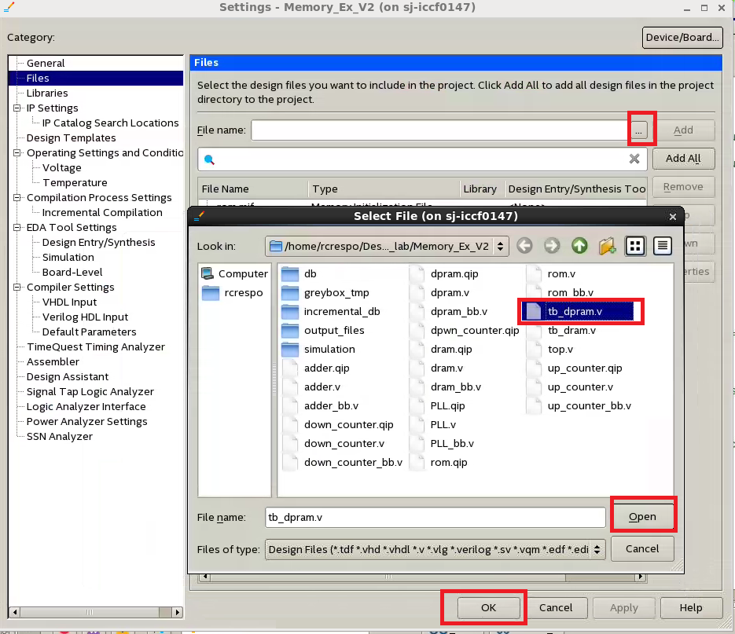
Figure 10: Opening Dual Port RAM
If you take a look at tb_dpram by double clicking on it in the Project Navigator File’s tab, top left drop down menu, you’ll see that the test bench instantiates the main clock, LEDR is tied to the output of the RAM, and then sets SW[0] = 0 (reset). Note that the ROM is your pattern generator for this design. The testbench just supplies a 50 MHz clock and the dual port RAM input address, data and write enable are generated through the design itself. We constructed the design this way so in the next step in the lab, you can see this in actual hardware.
To launch ModelSim for simulations you need to change the settings so that ModelSim can open through Quartus Prime Lite. Go to Tools Options EDA Tool Options. In ModelSim-Altera, enter the executable path. For finding the executable pathway, locate where the Quartus was installed by you (Usually in C:// drive in intelFPGA_Lite folder). Select OK when finished. Note if Figure 11: Linking ModelSim to Quartus. If you are running Quartus through Linux through NoMachine, you can ignore this part.
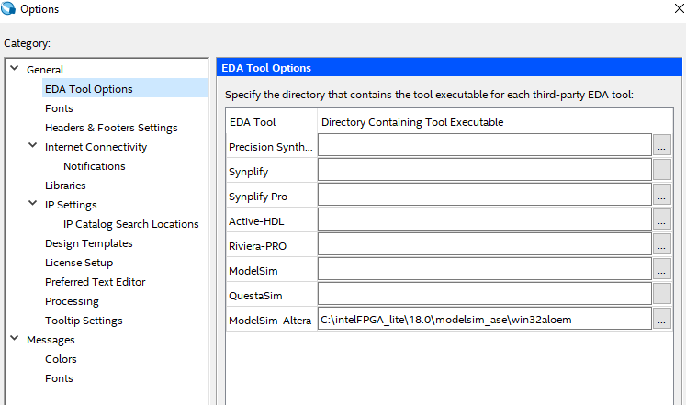
Figure 11: Linking ModelSim to Quartus

Under Assignment Settings Simulation. In the Test Benches Dialog Box, Click on New… Select the Test bench file to be added and Click Add. Name the test bench tb_dpram. Click OK. Note if Figure 12: Simulation Settings match your settings, then there is no need to make any changes.
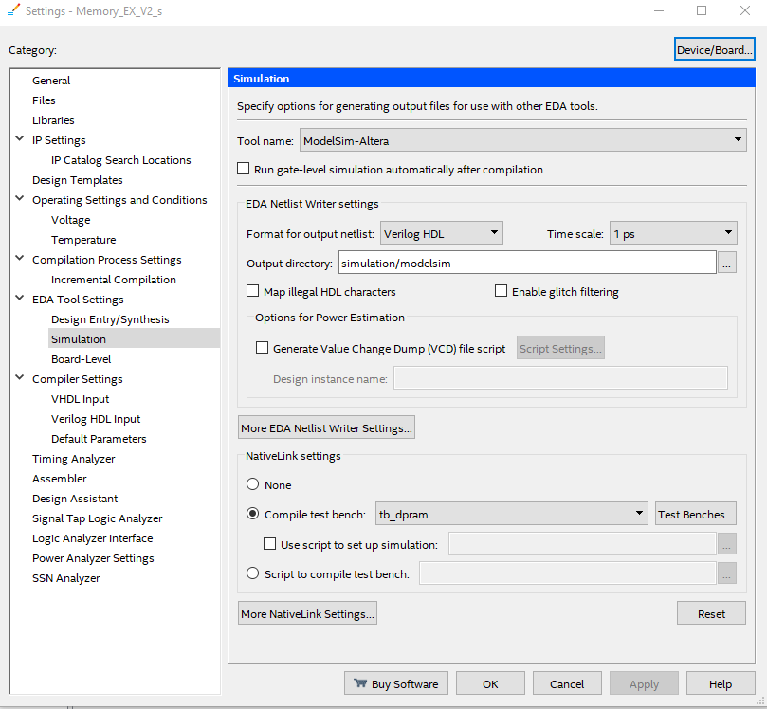
Figure 12: Simulation Settings

Once all the settings are in place. Hit 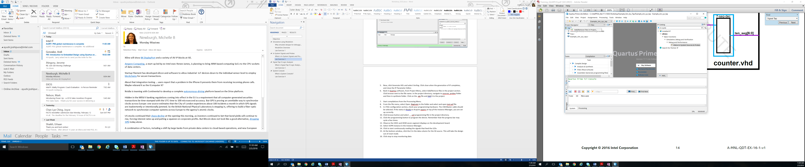 to compile the design in the Quartus toolbar. Next, from Quartus: Tools Run Simulation Tool RTL Simulation. ModelSim will launch. If you forget to compile the design you will get an error about Nativelink, ignore and compile and then run simulation.
Next, we are going to load a waveform formatting file that has the signals we want to study. In the Transcript section at the bottom of ModelSim, type do wave.do (we created this for you with interesting signals to look at) then press enter, you only need to do this once, followed by simulate restart, click Ok. Type run –all. The simulation is complete.
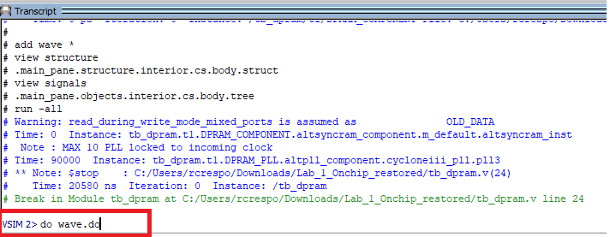
Figure 13: Transcript Window of ModelSim
Click on the wave viewer window tab. Then press (F) to zoom full. You’ll see two cursors. Click on the first one, then press (C) a few times to zoom in to active cursor. You should see something similar to the top of Figure 15: Simulation Results, which is below. All of the signals except for ‘clk’ are the signals associated with the Dual Port RAM.
Notice that on the first cursor sits on waddress (write address) is 36, the data going in is the 36 of the address + 66 from the offset in the ROM (36 + 66 = 102). Scrolling to the other cursor, where raddress (read address) finally gets to 36, the result in q(output of dpram) is 103, off by 1 because it needs one more clock cycle to actually output what’s on address 36, which matches! You have confirmed that the system is working for the 66 offset, and wren (write enable).
If you press F to zoom full, can you convince to yourself that wren = 0 works? How about when the offset is 67?
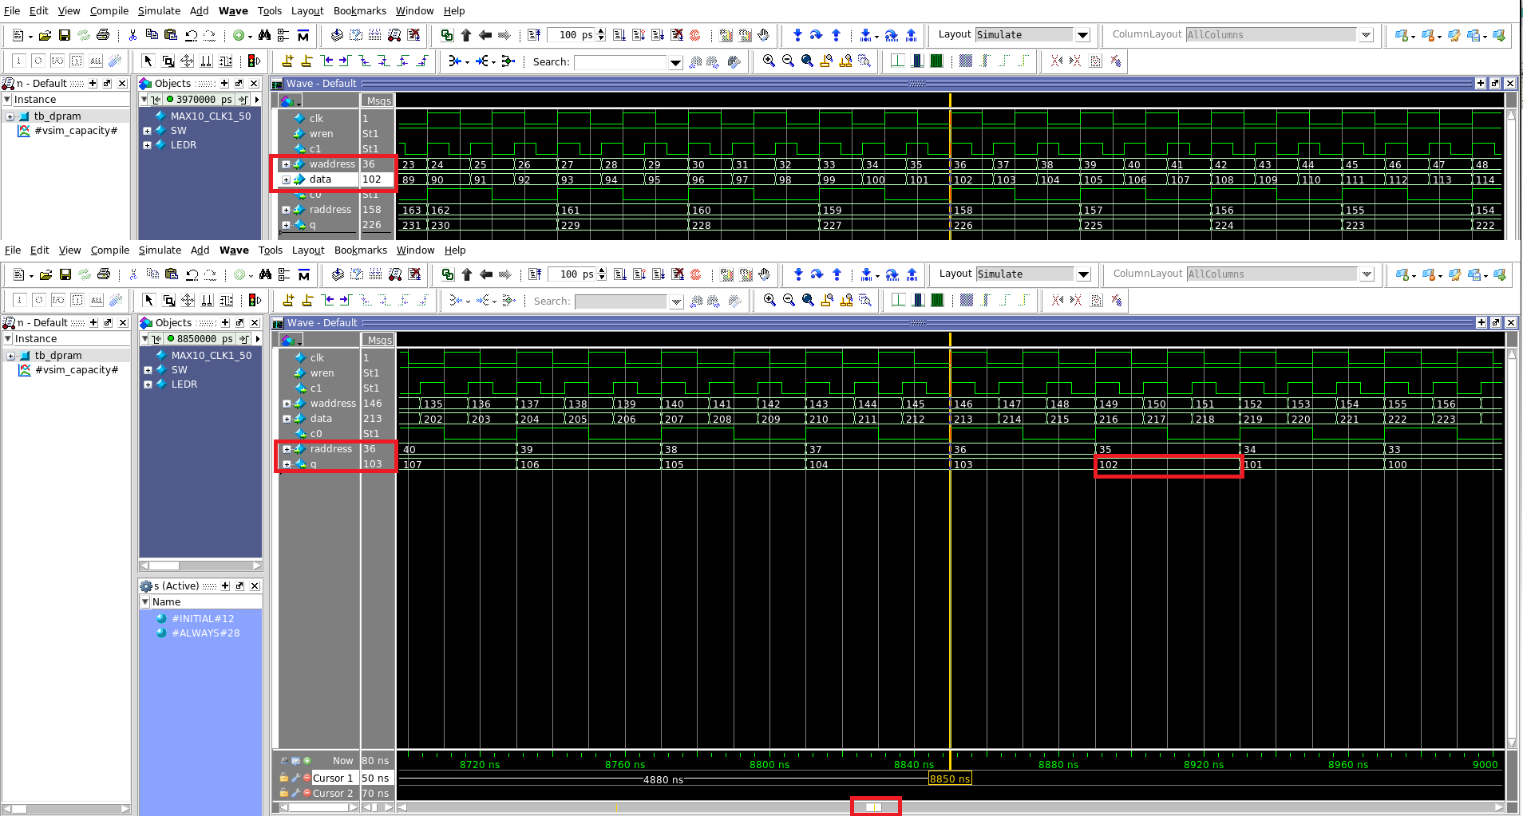
Figure 14: Simulation Results

Step 1.6: Program Board
Now that we know our design works in simulation, let’s proceed by programming the DE10-Lite board. The design should be compiled, in case it’s not, compile again by pressing.
Bring up the programmer by clicking, in hardware setup select ‘USB-Blaster’. If you don’t see USB-Blaster, your driver isn’t installed. Refer to the follow article for driver installation. Click add file, add the Memory_EX_V2.sof. Check the Program/Configure box. Click Start.
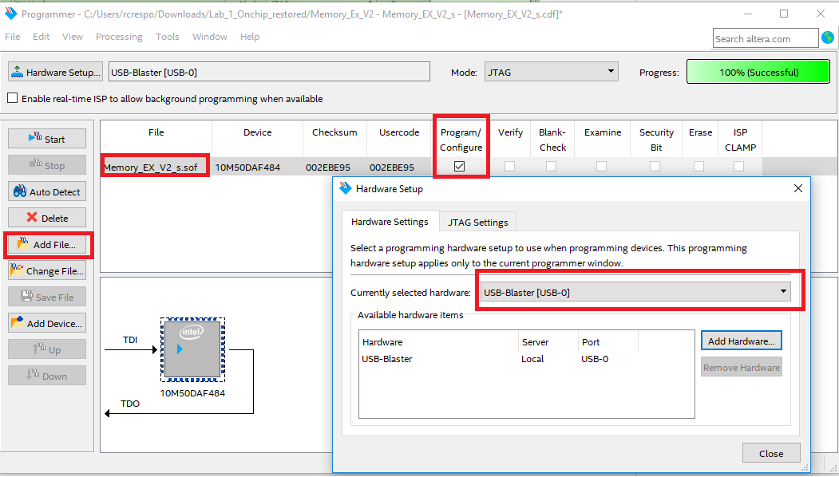
Figure 15: Programming the Board
You should now see LEDR[0-8] flickering at different speeds, the ones flickering slower since it takes dpram output q longer to reach the higher numbers.

Step 1.7: Observe in Signal Tap
Now we will load signal tap to confirm the implementation matches the simulation by observing the actual nodes in the FPGA device. Signal tap is kind of like a logic analyzer where you can observe actual signals transitioning inside your FPGA. This behavior should match your simulation if the stimulus is the same. Launch the application: Tools Signal Tap Logic Analyzer. Make sure auto_signaltap_1 in the Instance section is highlighted. Click on Run Analysis , on the top left, refer to Figure 17: Signal Tap results below.
Note the capture of a thousand samples. For your convenience, a time bar capture -366 is placed, observe that waddress is 36, and there is a 66 as offset (bits{7:0] from ROM to adder), summing to 102. At the center of the waveform (the trigger or capture 0) the raddress (Read) is 36, and again, just like in simulation, it takes one read cycle (equivalent to three write cycles) for the output to show what’s on address 36, which is 102. The implementation matches simulation! Refer to Figure 17 below to see these results in action.

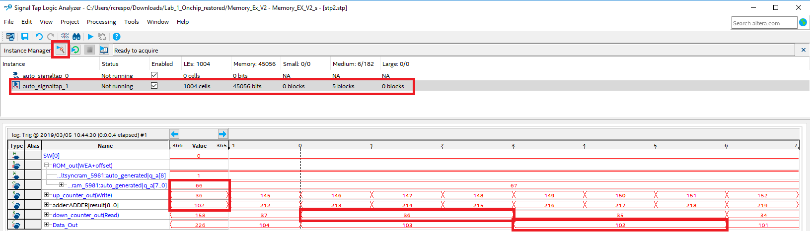
Figure 16: Signal Tap results
Tha capture runs at the same speed as the 75MHz clock, if there is a difference of 366 captures for reading a write, how different is that from the one in simulation?
Congratulations! You have completed lab 1.

Design Flow for an External SDRAM
When developing a system that includes external memory, the design flow described below is taken into consideration. In order to save time for this workshop, we’ll start in the ‘Specify Parameters for your EMIF (External Memory Interface) IP’ section.

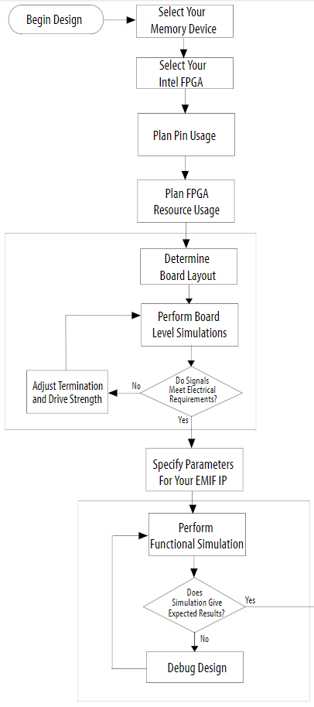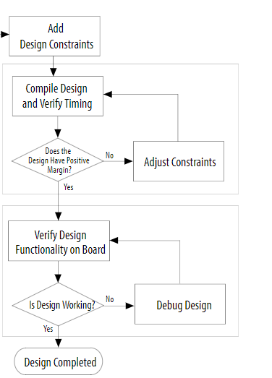
Figure 17: EMIF Design Flow
Each step on the tutorial maps to a task described in the previous flow. Even on a small design as the one described in this document, following all the steps will ease external memory bring up on the smaller amount of time. Many steps are already completed in this workshop such as DRAM memory selection and board layout and analysis.
- Step 1: Install tutorial files
- Step 2: Open project and review design
- Step 3: Signal Tap
- Step 4: Switch to on chip
- Step 5: Signal tap
- Step 6: Compare

Utilizing the FPGA External Memory Interface IP

Block Diagram
This design is a bit more complex than the previous one. It includes: A Nios II Soft Processor, a PLL, some GPIO, a UART to talk to a host an external SDRAM controller, the SDRAM itself. In this case the SDRAM controller takes care of most of the processes we need in order to boot and run from SDRAM without building address counters around it. Some IP components are in the Platform Designer’s system, but we won’t be using them for this lab, these include: Sysid, Timer, Key, and Switch.
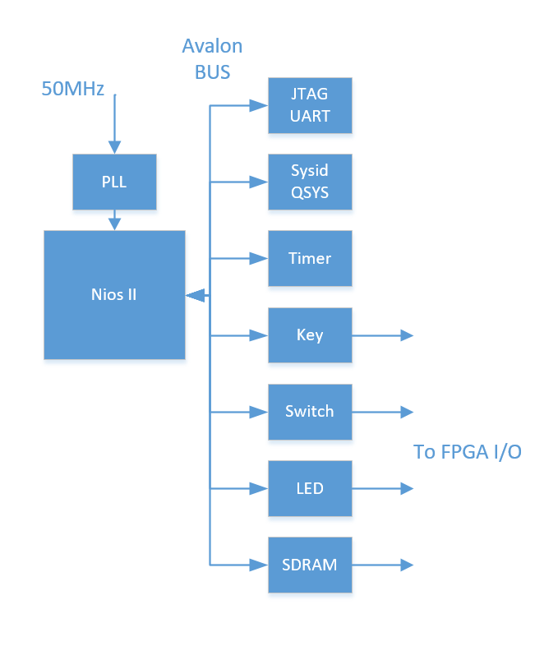
Figure 18: Initial EMIF System Block Diagram

Step 2.1: Install tutorial files
You can download the lab files from this link: ‘Lab_2_EMIF.zip’ to your computer. This tutorial expects that the destination folder of the project files is the root directory of your computer (C:\). If you are using a different location, make sure that you adjust all reference to the project directory accordingly.

Step 2.2: Open project
After download, right click the .zip file and do extract all, extracting to a location with no spaces on the name.
Open Quartus lite, then click ‘File’ and select ‘Open Project…’
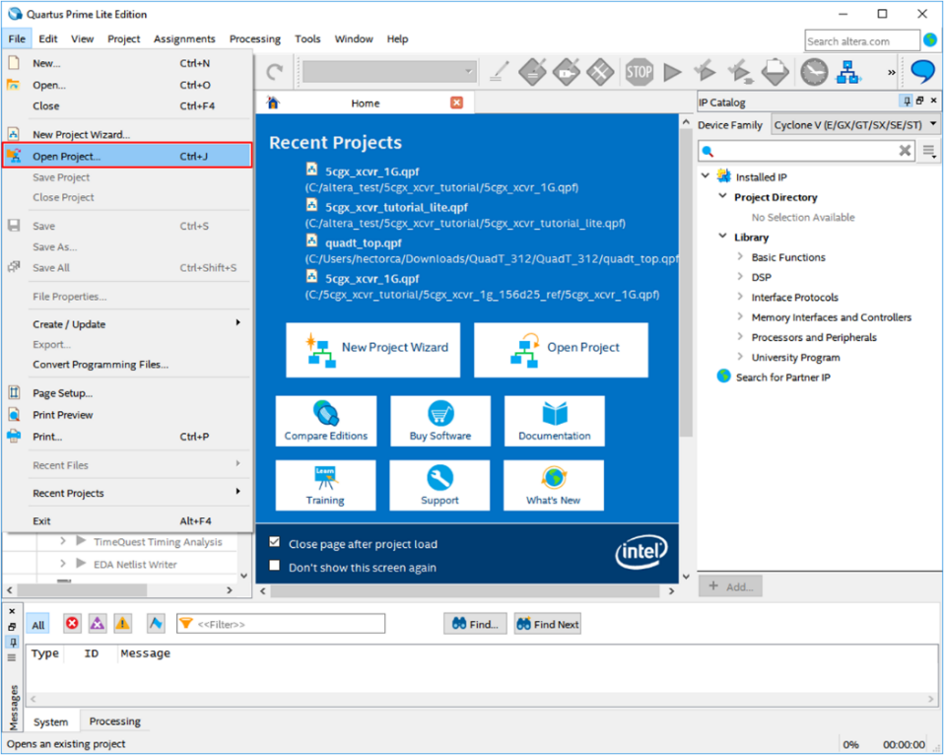
Figure 19: Opening Archived project
Select the ‘DE10_SDRAM_Nios_Test.qpf’ file you downloaded, then click ‘Open’.
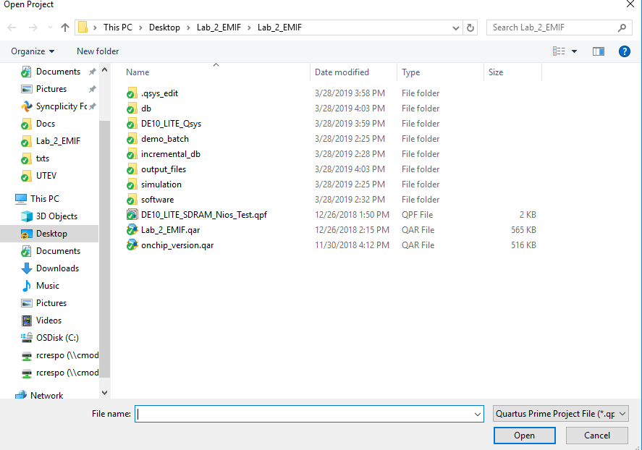
Figure 20: Opening Lab_2_EMIF.qar

Click Ok on next prompt.

Step 2.3: Setting up the Software
In Quartus select Tools Nios II Software Build Tools for Eclipse. The default workspace is Ok, just make sure there is no blank spaces in the path. If there is anything in the project explorer make sure to delete it. Now right click on the project explorer select File>New> Nios II Application and BSP from Template. Browse for your SOPC info file by clicking ‘…’. The file should be in the main project folder, it’s called ‘DE10_LITE_Qsys.sopcinfo’, name the project ‘Deed’. Select Hello World Small from the Template and click Finish.

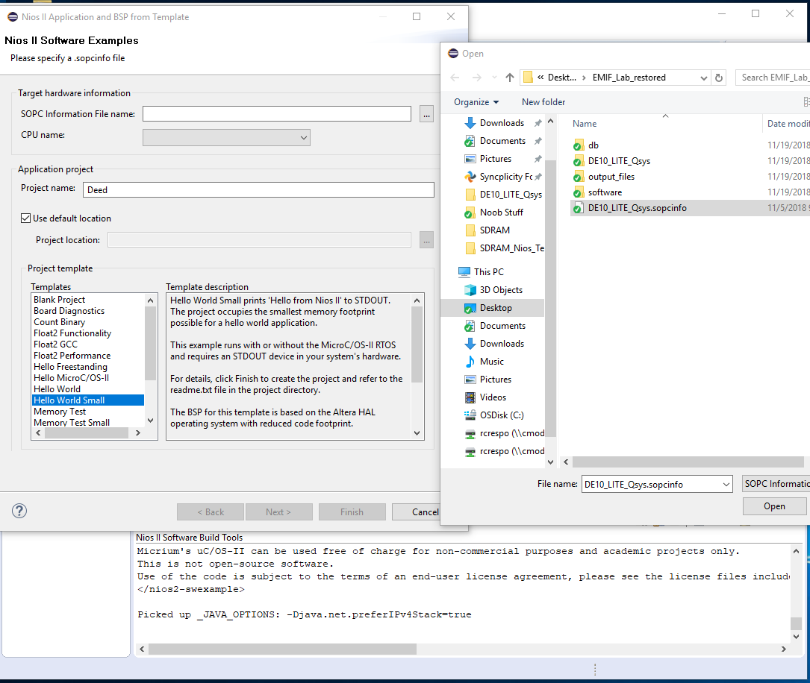
Figure 21: Selecting sopcinfo in Eclipse

In order to make sure the Board Support Package (BSP: Provides drivers) is correct, right click in the Deed_bsp folder and select Nios II>BSP Editor. Go to the Linker Script tab, and make sure that everything matches, this links all the code execution correctly to the SDRAM, click Exit.
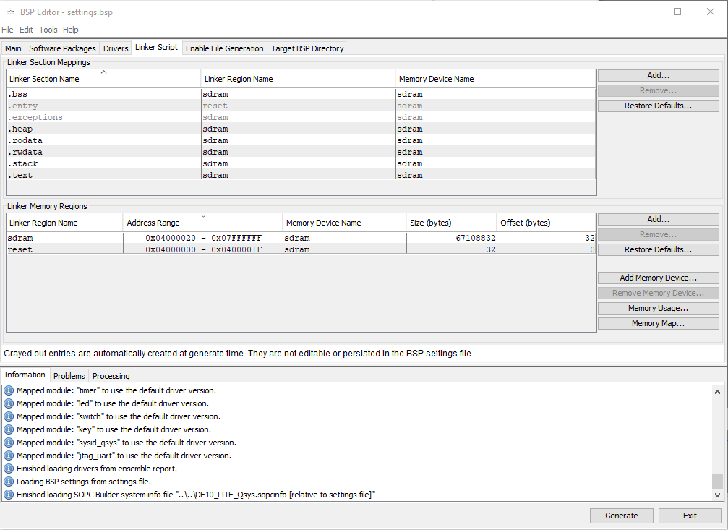
Figure 22: Confirming Linker Script

Open the Deed folder in the File Explorer, delete hello_world_small.c, we will replace this with another source code.
Bring up File explore and navigate to where you stored your project. In it navigate to software, you’ll find a reverse_deed.c file in it, drag it to the Deed folder in Eclipse, copy files option is ok, click ok. Double click in the Deed folder.
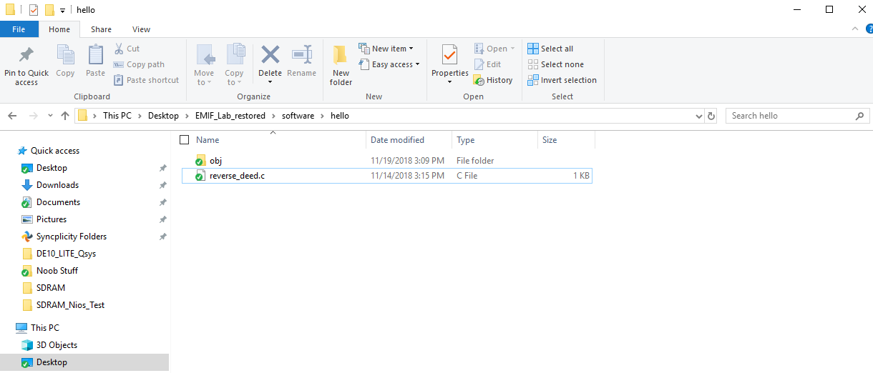
Figure 23: Selecting C File
Source file reverse_deed.c is creating pointers, initializing them to an Avalon Bus address, then writing 0xDEED into those pointer addresses. It’s a simple method that helps us take a look at how the program writes data into an address in hardware. At the beginning we turn on LED[0], at the end we turn on LED[1]. There are some comments with pointer assignments, don’t worry about those for now.
Now right click in the Deed folder, click on Build Project.

Step 2.4: Signal Tap SDRAM
Now we will bring up signal tap, the tool that lets us observe signals on the SDRAM controller in the FPGA, triggered and captured for our analysis. At the top, Click on ToolsSignal Tap Logic Analyzer.
There should be three signal tap instances in the instance window, make sure enable only auto_signaltap_1 by checking the box, then double click on auto_signaltap_1.
Select the setup tab at the bottom of the middle window to understand the triggering method. Trigger means the same thing as it sounds, something matches, and the capture is triggered to save and display in the data around the trigger.
For auto_signaltap_1 note that the only trigger enable checked is the jtag_break. JTAG (Joint Test Action Group) is an industry standard interface for verifying component connections on PCBs after manufacture but is also used as a means to interface to the FPGA through a bridged USB connection called a USB Blaster. It resides after the USB connection, and makes it possible to monitor internal nodes within the FPGA. This signal tap instance is only storing transitions, because continuous would capture on every clock and store close to 3x the data of the transitions method of data collection. Which is unreasonable for the amount of memory in the MAX 10 used here.
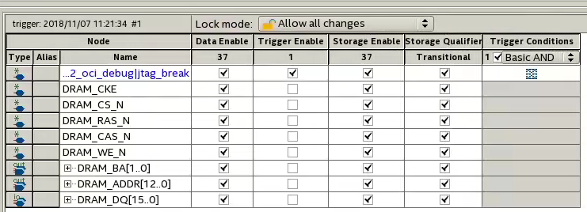
Figure 24: Confirming Trigger
At this point Compiler hasn’t happened, we need this to program the board and run signal tap, hit Start Compilation at the top of the Signal tap window. After compilation is complete, hit run analysis (F5) at the top left of Signal Tap

When complete, go back to Eclipse, select Run as Nios II Modelsim. Then go back to Signaltap.
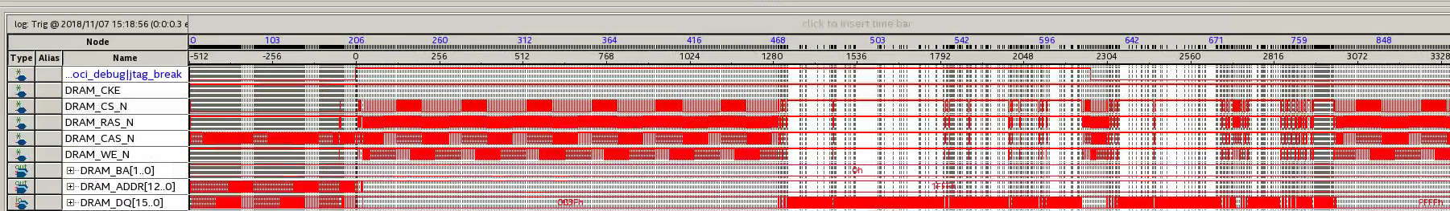
Figure 25: SDRAM Signal Tap Results
This is important because we can see something that isn’t possible to see in simulation, how the C code is being downloaded into the Nios II and SDRAM. The simulation bypasses this step by “magically” preloading the memory.

Go back to eclipse, stop the program from running by clicking the red Terminate and Remove Launch button in the bottom right section.
Now, make sure only auto_signaltap_2 is selected checked. Compile again, and program the board as previous by using the programmer.
In the signal tap setup, you’ll see that this instance is set to trigger when 0xDEED is observed in the DRAM_DQ pins. The C code in Eclipse initializes pointers, then writes to the address the pointers is pointing towards. This way, we observe the code executing, 0XDEED being written into the addresses in the C code.
Click run analysis (F5) at the top left of Signal Tap, then go back to Eclipse and right click the project folder, run as Nios II hardware. Bring up signal tap again, it will trigger at 0xDEED when is ready, then offload the data. Click on the center waveform on trigger. 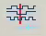
In Figure 26: SDRAM Command Truth Table indicates the commands issued to SDRAM by the signals you see in Signal Tap. Can you figure out the commands in and around the two red rectangles in Figure 27: SDRAM ACT and Write Commands in Signal Tap? That’s what we will explore next.

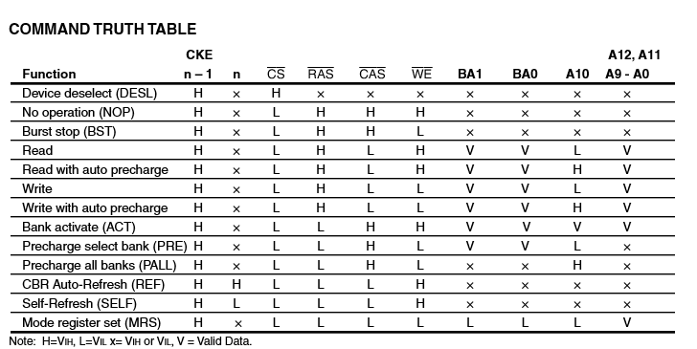
Figure 26: SDRAM Command Truth Table

Observe the datasheet section below for the SDRAM part: the write command. You’ll see the mechanics of row, column, and bank capturing below. The row goes first when ACTIVE command is issued, essentially opening a row or ‘page’ of memory, then the WRITE command is issued later, the column is captured and 0xDEED appears in the DQ pins, being written into the specific address, which a combination of the address and BA pins in those two command separated by the NOP (No operation) command.

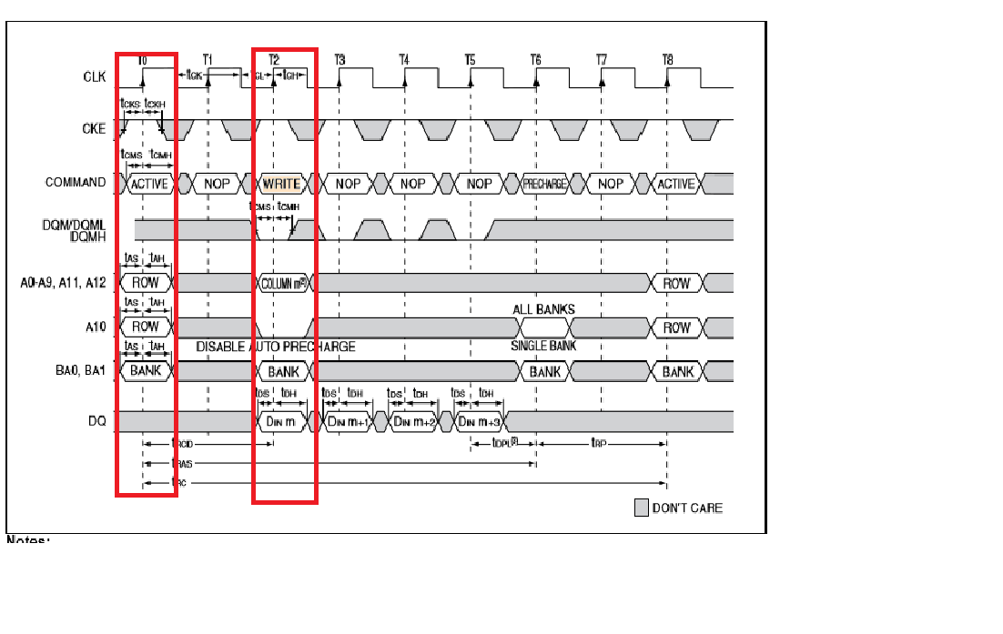
Figure 27: SDRAM Data Sheet's Write Command
The picture below should match your signal tap, instance, by following the truth table and comparing it to the data sheet write command, can you see how they match?
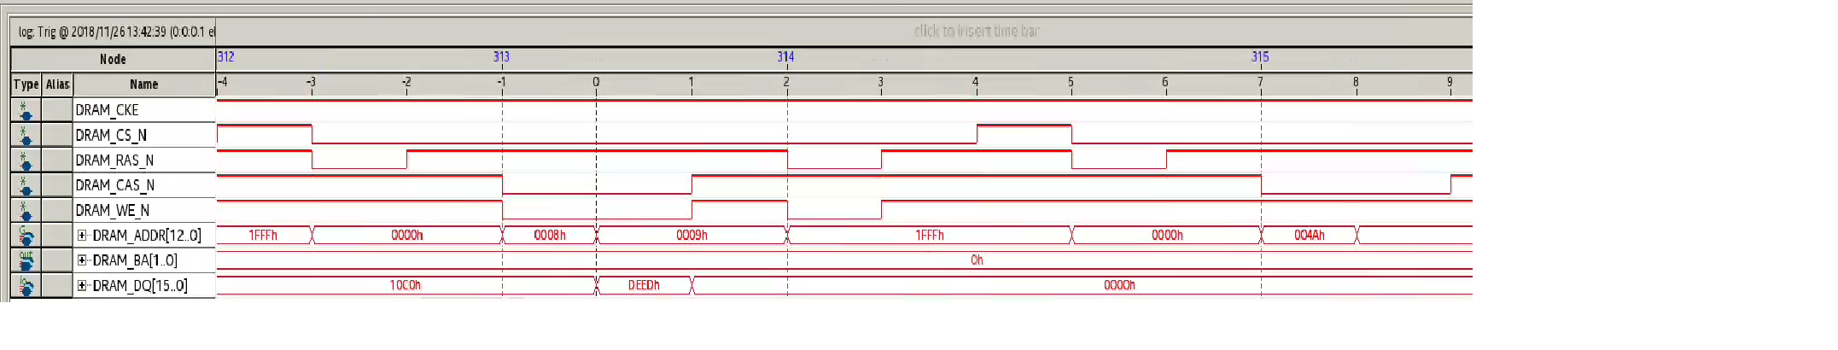
Figure 28: SDRAM ACT and Write Commands in Signal Tap

Now, the first pointer goes to address 0x400001, none of these numbers are seen anywhere in the address pins! What’s going on? In order to understand this, we need to understand row, column and bank organization, as well as Avalon bus to SDRAM controller address shifting. These are difficult things to figure out without reverse engineering since documentation was a bit sparse on the SDRAM controller IP. Let’s break it down through an exercise.

Exercise: Address Decoding
According to the Avalon interface guide, through the table below, you can match how many bits are offset from left to right on the Least Significant Bit (LFB), we have a 32 bit master, a 16 bit slave, we ‘access’ (burst) twice (16 bit each), meaning that we have an OFFSET of 3 bits, everything shifting three bits to the left.
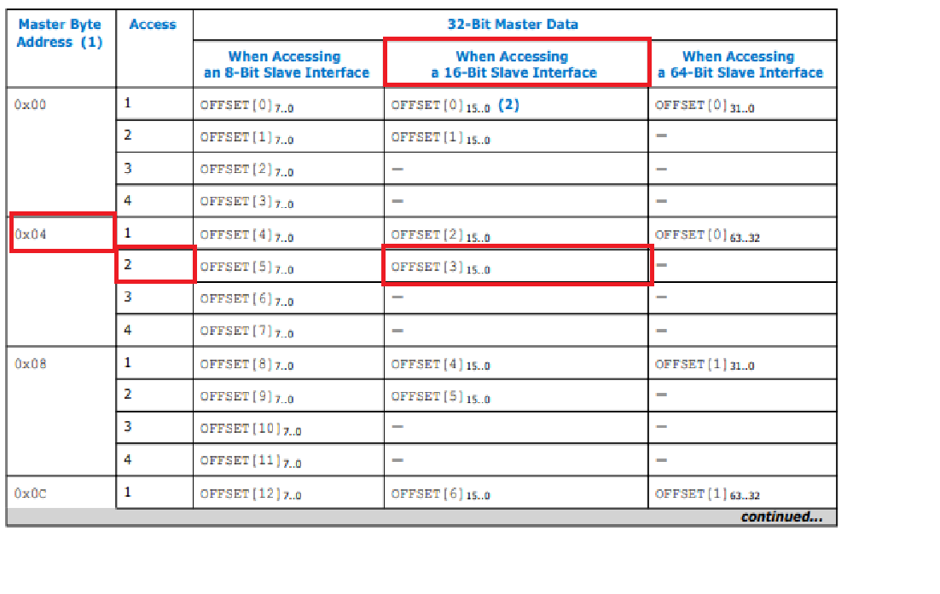
Figure 29: Address Decoding Settings for Avalon Interface
After this happens from the Avalon bus, at the SDRAM controller level, the addressing is manipulated again. This time we only care about bits 24 down to 0. That’s why we’ll never see the 4 (bit 26) in the SDRAM address pins.
The 25 bits are arranged as: B[1] : Address[24], Row[12:0] : Address [23:11], B[0] : Address[10], Col[9:0] : Address[9:0]. Remember, this is all after 3 bit offset to the left.
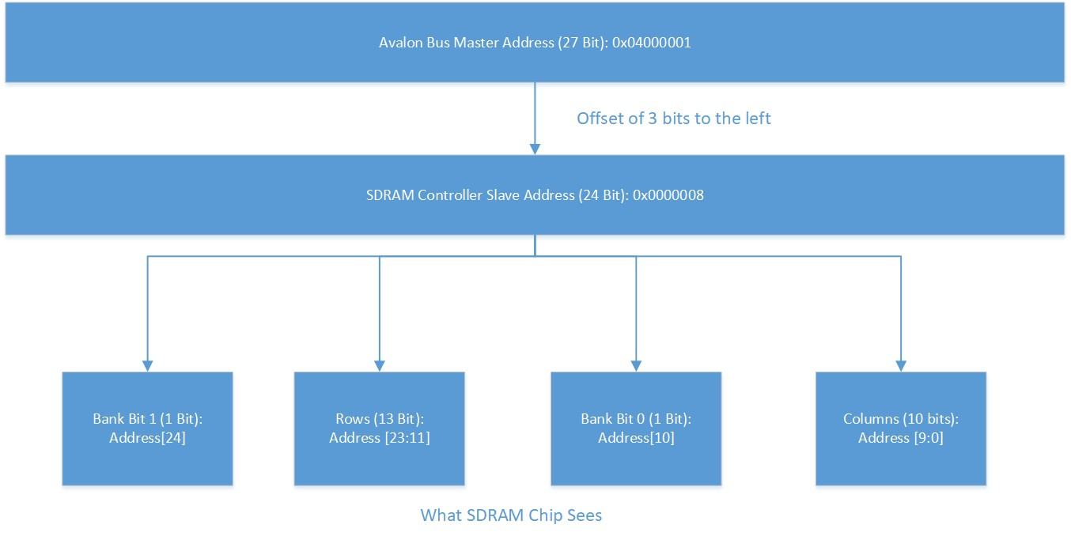
Figure 30: Flow for Address Decoding

Quiz
How are the 7 register addresses in reverse_deed.c would be represented in terms of row, column, and bank bits?
Now if you go back to signal tap, right click on SDRAM_DQ, click on find bus value, fill in DEED, make sure hexadecimal is selected, and click find next. You’ll see that there are 7, matching the code in Eclipse. Does everything match your expectations when it comes to addressing? The transitions in between DEED write are 28, keep that in mind.
The solution can be found in each DEED in the Signal Tap Instance.

Step 2.5: Switch to on-chip Design
Now we will switch the design to boot and run from on chip memory instead of SDRAM, then compare timing. But first make sure that the program in Eclipse stop running by going back to eclipse, and stopping the program from running by clicking the Terminate and Remove Launch button in the bottom section.
Open Platform Designer by going Tools Platform Designer, which is a tool that makes all connection in a design work by generating the hardware description language (HDL) through a GUI where the user picks IP and connects it together, this was previously from this lab.
It will prompt you to open a .qsys file, select ‘DE10_LITE_Qsys.qsys’ in the file explores in the project folder, hit open. Now you’ll see the design corresponding to Figure 18: Initial EMIF System Block Diagram above.
Deselect the check box for SDRAM. Select greyed out line checkbox for on chip. Refer to Figure 27: Switching Design to On Chip below.

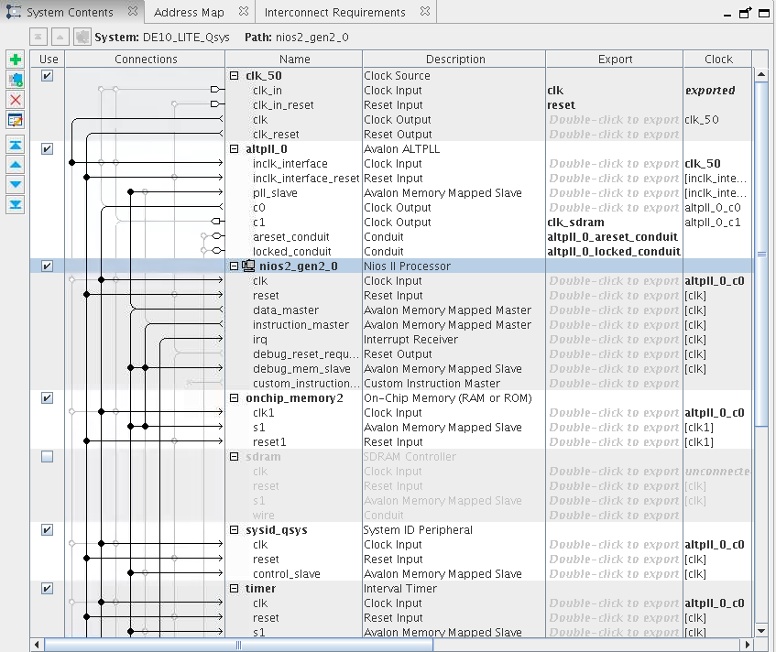
Figure 31: Switching Design to On Chip
Double click onchip_memory2. In the parameters window, under the Size section, notice that the memory size is 100KBytes, way smaller than SDRAM’s 64Mbytes. Check the box for ‘Initialize memory content’.
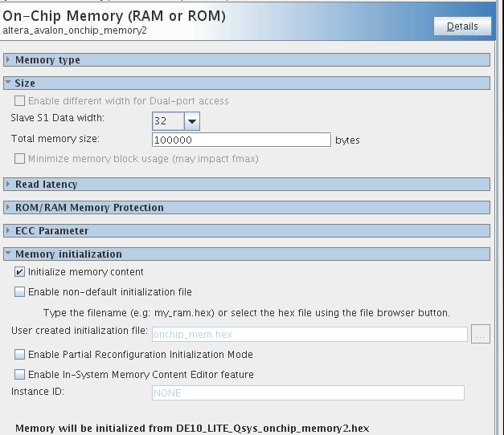
Figure 32: Initialize Memory Content
Double click on the nios2_gen2_0 processor and in click the vectors tab, switch the interrupt and restart vectors to ‘onchip_memory2.s1’.
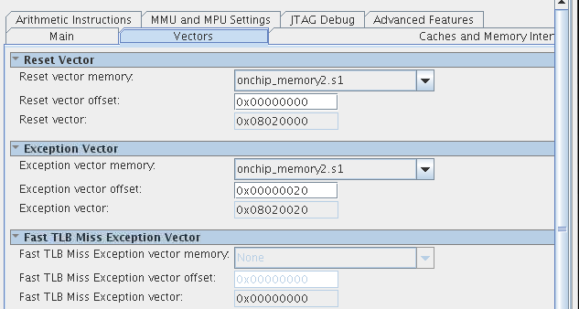
Figure 33: Setting Reset & Exception Vector
Next, hover over the ‘System’ tab ‘Assign Base Addresses’ this changes the addressing to make sense for the memory size of the current system.
Now save, then click ‘Generate HDL’. After generation is complete, go to Quartus Prime and edit the design by commenting out the SDRAM exports as shown below, by putting a ‘/*’ at the start of your commenting, and a ‘*/’ at the end. You get to DE10_LITE_SDRAM_Nios_Test.v by double clicking it in the project navigator window.
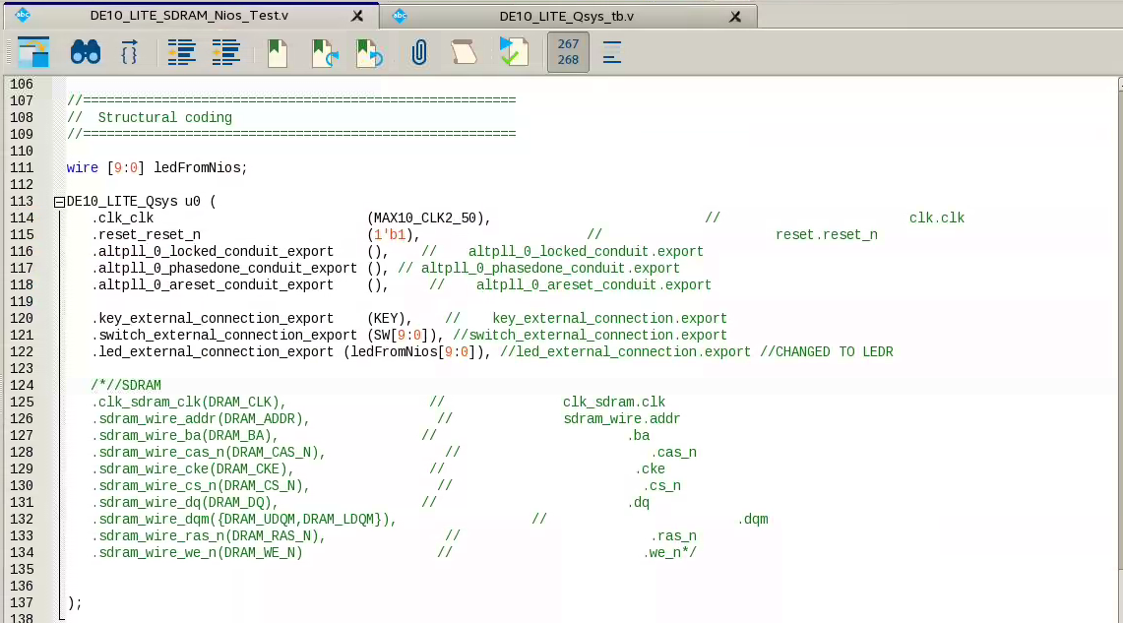
Figure 34: Modifying Top File

Step 2.6: Signal Tap On-Chip Design
To finish off, we will run one more Signal Tap instance, this one will demonstrate the amount of transition in between writes in comparison the last signal tap run on SDRAM. Open signal tap, and enable only auto_signaltap_3 in the instance manager, then double click it. In the setup tab, you’ll see something similar to step 2.4 with the second instance, triggering off DEED in the writes.
Now compile Design and program board as before.
Open Eclipse back up, right click in the BSP folder, do Nios II BSP Editor…. Go to the Linker Script tab in the editor, then hit Restore Defaults and make sure it matches Figure 34: On Chip BSP Editor below.
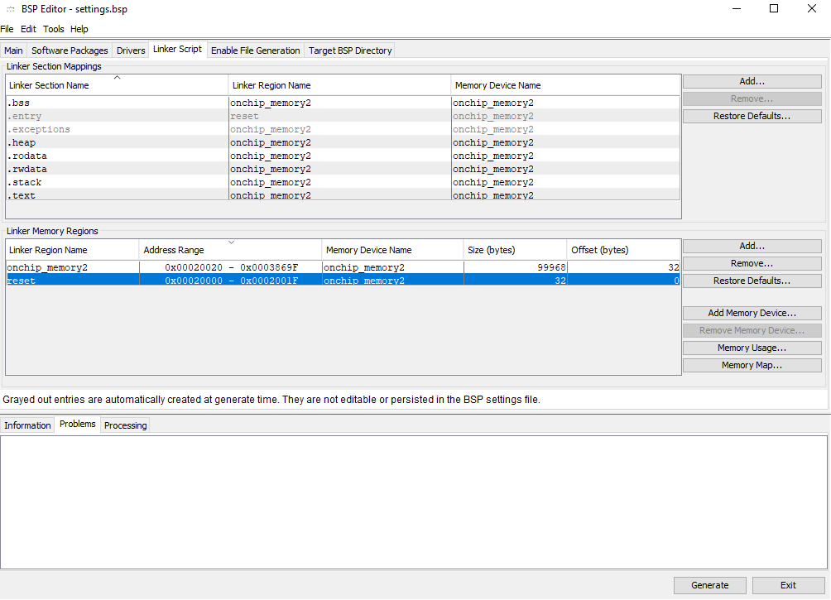
Figure 35: On Chip BSP Editor
Next comment out the SDRAM address assignments, and comment in the on chip memory assignments in reverse_deed.c. This switch will let the registers point to the on chip addresses instead of the now nonexistent SDRAM addresses. Follow Figure 35: On-Chip C code setup below to switch the code to On-Chip. Save all at the top of Eclipse (Cntrl + S)
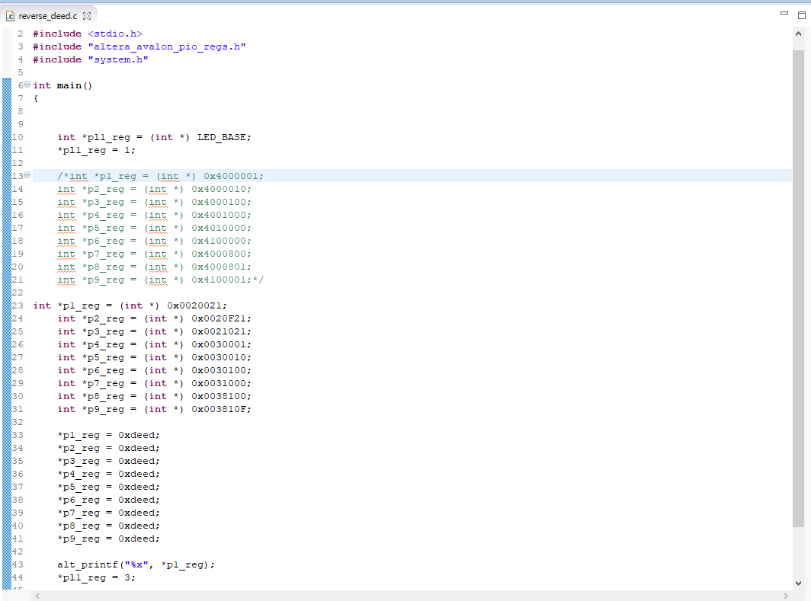
Figure 36: On-Chip C code setup

Go to Signal Tap and hit Run analysis
Go back one last time to Eclipse, Right click the project folder, run as Nios II hardware. It will take some time but your Signal Tap instance should look something like below Figure 36: Signal Tap Results for On-chip.
As you can see below, this time it only takes 9 transitions from from one DEED write to the next, instead of 28 for SDRAM, a 3X improvement! That’s without taking into account the latencies, which is 1 cycle for the onchip slave, and 3 cycles for the CAS on SDRAM.
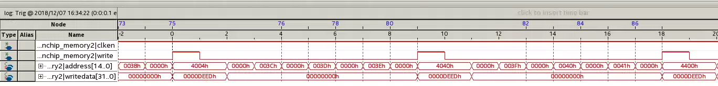
Figure 37: Signal Tap Results for On-chip

Step 2.7: Compare
Below is a table that summarizes most differences that we encounter for the second lab when it comes to SDRAM vs On Chip. Setup being the time of ‘inactivity’ the memory needs to start functioning as expected, this only matters on memory initialization. The numbers are derived from the Signal Tap runs we did, but also from the Simulation section found in the Annex.

Category | SDRAM | On Chip | Diff (On Chip/SDRAM)
Clock Rate (MHz) | 100 | 50 | 0.5X
Storage (KBytes) | 64,000 | 100 | 0.0015625X
Execution Time (us) | 70.58 | 26.26 | 2.69X
Execution Time (Cycles) | 7,058 | 1,313 | 5.38X
Exec. + Setup (us) | 190.12 | 34.11 | 5.57X
Exec. + Setup (Cycles) | 19,012 | 1,701 | 11.18X
Cycles/Line of C | 371.5 | 69.1 | 5.38X

What conclusion do you draw from the comparison above?
Congrats you’ve completed this lab!

Appendix

Step 2.9: Simulate with the Avalon Bus Functional Model
Note: Section 2.8 and 2.9 are a work in progress, flow to be reviewed.

Instead of setting up the simulation, this time we’ll let platform designer’s already generated testbench, then simulate the C code in Eclipse by launching ModelSim in that same tool.
We will use the Eclipse tool to simulate the Nios II and SDRAM in Signal. Note that the reason we have to use this tool instead of making a custom test bench is because we are using a Bus Functional Model (BFM) and a test bench generated by Platform designer. Some of the test bench components are encrypted, and therefore unreadable by ModelSim by itself, this is where Eclipse comes in and translates for ModelSim.
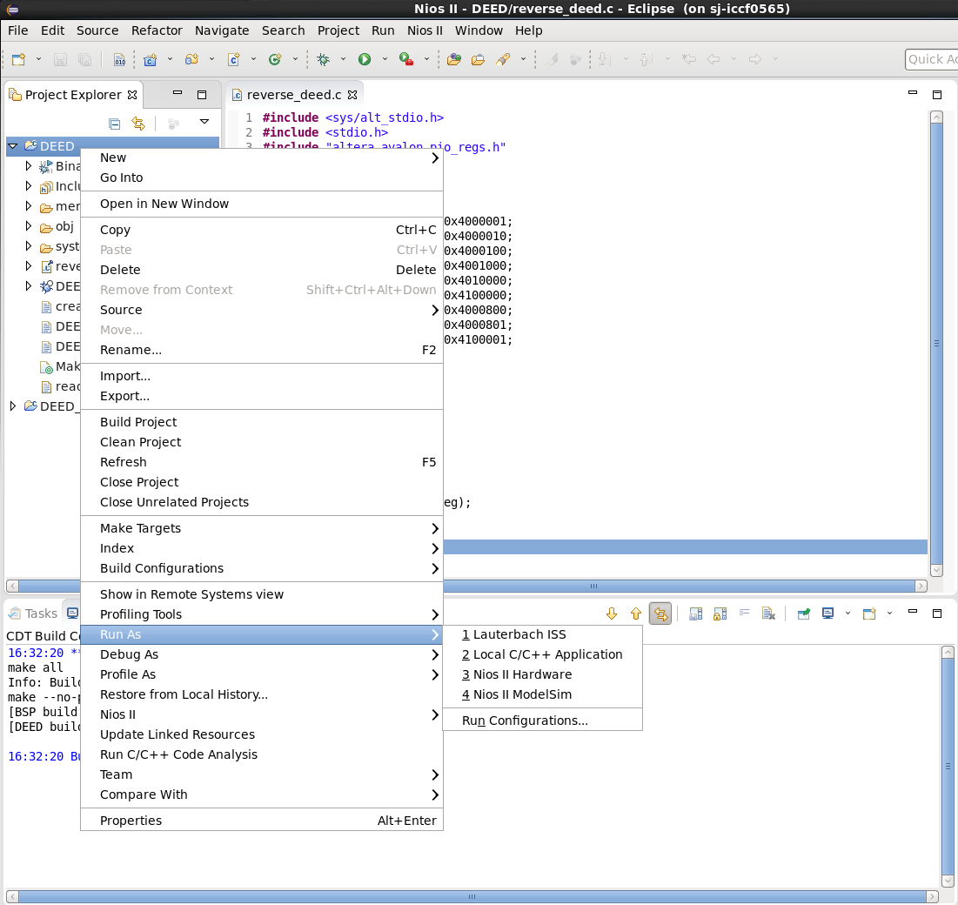
Figure 38: Running ModelSim

In order to make things faster we have a wave file ready. In the transcript window, type do wave.do press enter. Now type run 250 us, press enter. When Modelsim is close to completing the 250us simulation you should see “DEED” on the transcript window, as well as some waveform above.

Click on the Wave window, now click on Zoom Full.
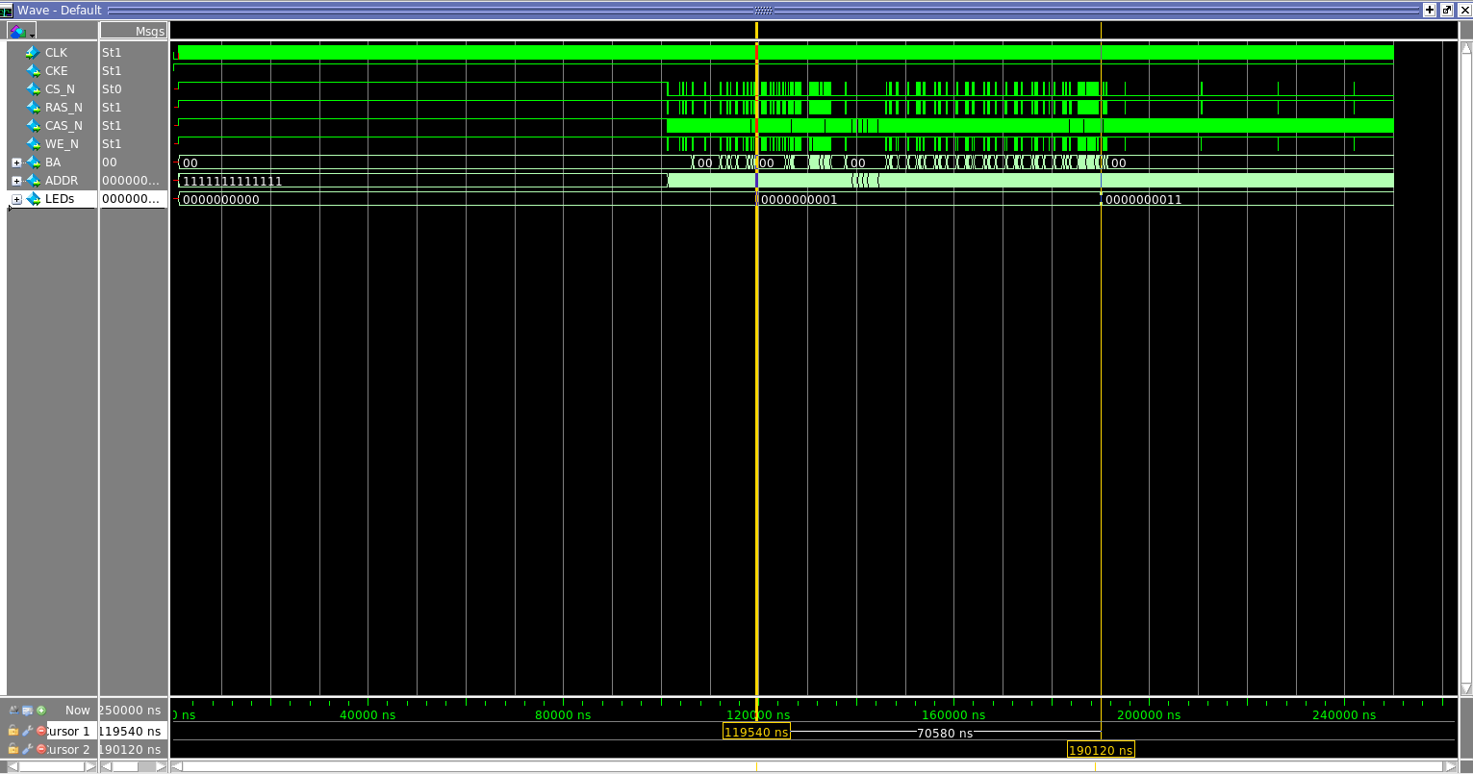
Figure 39: SDRAM Simulation Results
As you should be able to see in your screen, there are three very distinctive periods of activity in the SDRAM before the system prints ‘DEED’: No activity initialization, high activity when the code runs, and low activity when other parts in the system are printing ‘DEED’.
The time bars should be locked to the LEDs row, where we can observe the change from 0 to 1 to 11, representing the LEDs that are on. This way we observe it takes SDRAM 7,058 cycles (70.58 us) to execute 19 lines of C code, 19,012 if you count the period of inactivity.

Figure 27 illustrates a write to memory, specifically the first write to the pointer address we created called p1_reg. We will explore the mechanics of this in the next section. Note the time it took to get to line number seventeen in ‘reverse_deed.c’ tab in Eclipse.
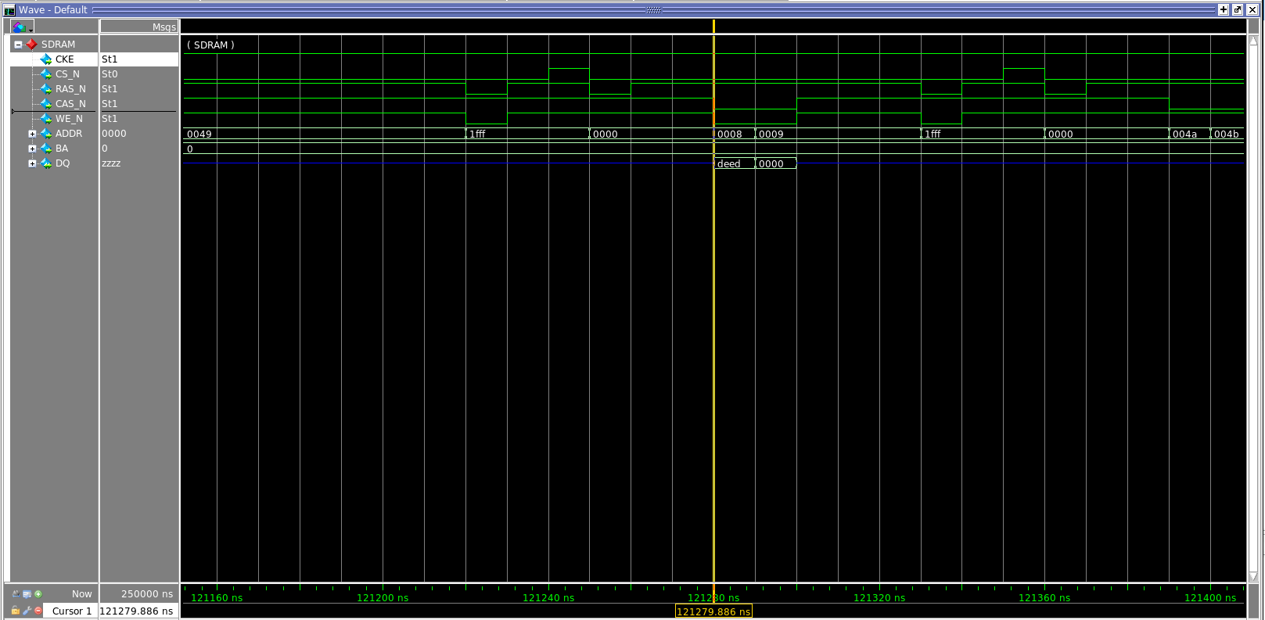
Figure 40: ACT (Bank active or page pull up) and Write Instructions

The point of this simulation is to understand these key takeaways:
- The inactive period emulates what happens when the .elf (executable and link format) file goes into the board, but it doesn’t really capture what’s actually happens since (besides the time it takes) it wasn’t considered for the Bus functional model. .elf is the file loading all the instructions of the C program with all the associated libraries and board support packages into the board. We’ll explore the .elf download in the next section.
- The time it takes, you should note down the time that it takes to print ‘Deed’, as we will compare it to the on chip memory later. We can’t observe the actual time it takes in Signaltap because we store the data by transitions as opposed to each clock cycle in order to save the amount of FPGA memory needed to run Signaltap.

Step 2.8Modelsim and Compare
… Make sure Standard, BFMs for standard Platform interfaces is selected, click generate. At the end you’ll see Generate: completed with warnings, click on the warning symbol, you should see something similar to what’s below.
The first warning lets us know that the bus functional model use in the testbench doesn’t have a clock associated with it, without it ModelSim won’t work, so we’ll fix that in Quartus. The second one we can just ignore.
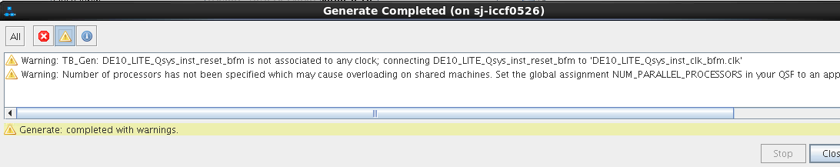
Figure 41: Warning about BFM

Now, just in like in step 3 of this lab, we will do a ModelSim simulation of the platform designer system by using Eclipse. In Eclipse right click on the DEED_bspNios II BSP Editor…

Now do FileOpen under DE10_LITE_Qsys/testbench/DE10_LITE_Qsys_tb/simulation open DE10_LITEQsys_tb.v Line 18 should be replaced from this:
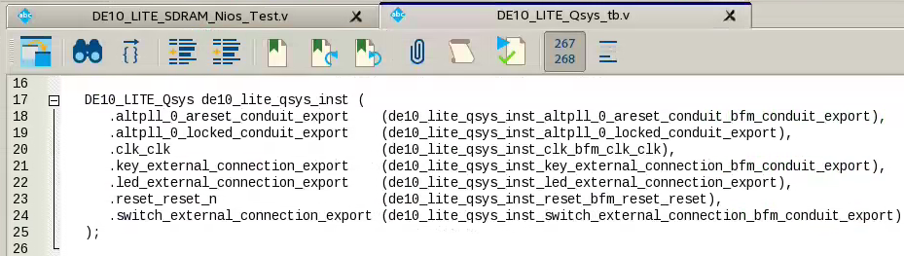
Figure 42: Initial Conduit Export Connection

To this:
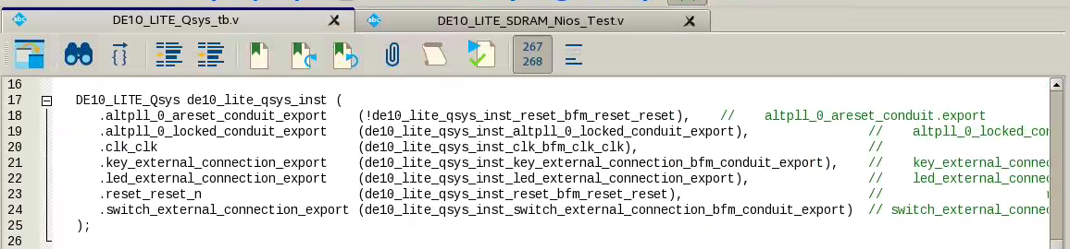
Figure 43: Modified Conduit Export Connection
This will associated the proper reset to the BFM, that’s: !de10_lite_qsys_inst_reset_bfm_reset_reset

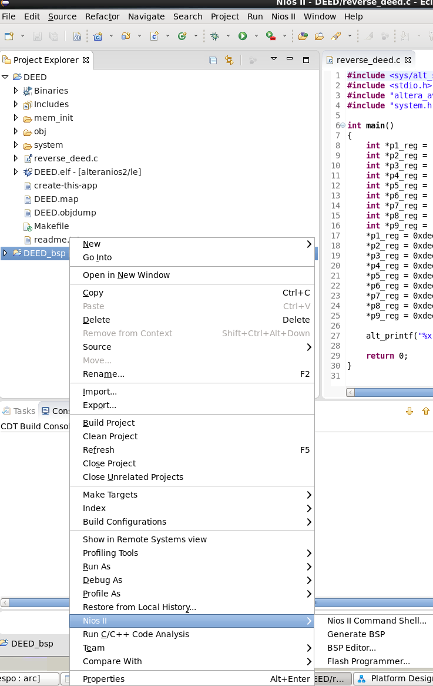
Figure 44: Opening BSP Editor
Go to the linker script section and click restore defaults, then generate. When generate is complete, you can exit. This step restores the board to run entirely out of on chip memory.

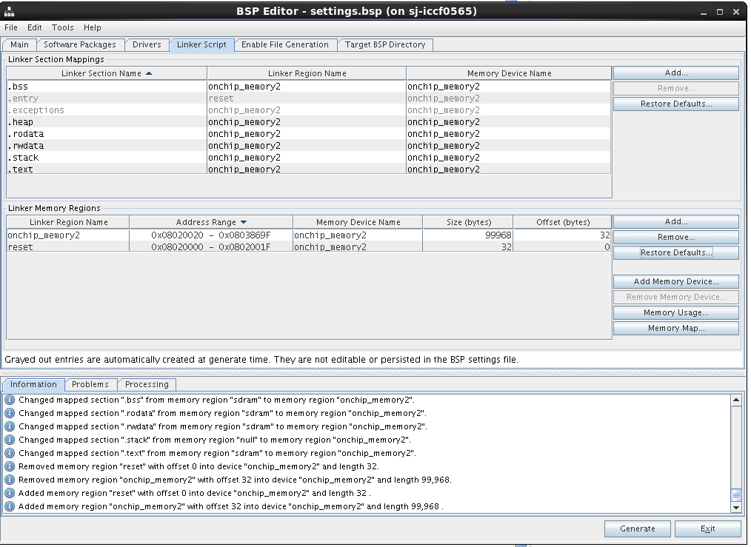
Figure 45: Selecting On Chip Memory

Since we changed the addressing in platform designer, we need to change the addressing in the c code as well. Comment out the block of pointer assignments with ‘/* */’ and uncomment the other ones, just like below.

You’ll observe that the pointers point to addresses stating at 0x0020021, that’s where onchip starts (after resets) you can look back to the linker script window in the BSP editor for that.

Now right click on ‘DEED’ folder and click on generate project. Then right click again and do Run As Nios II ModelSim. Then type ‘do wave_onchip.do’ Enter run 50us Enter. Now click on the top blue section of the wave window, then zoom full (F).
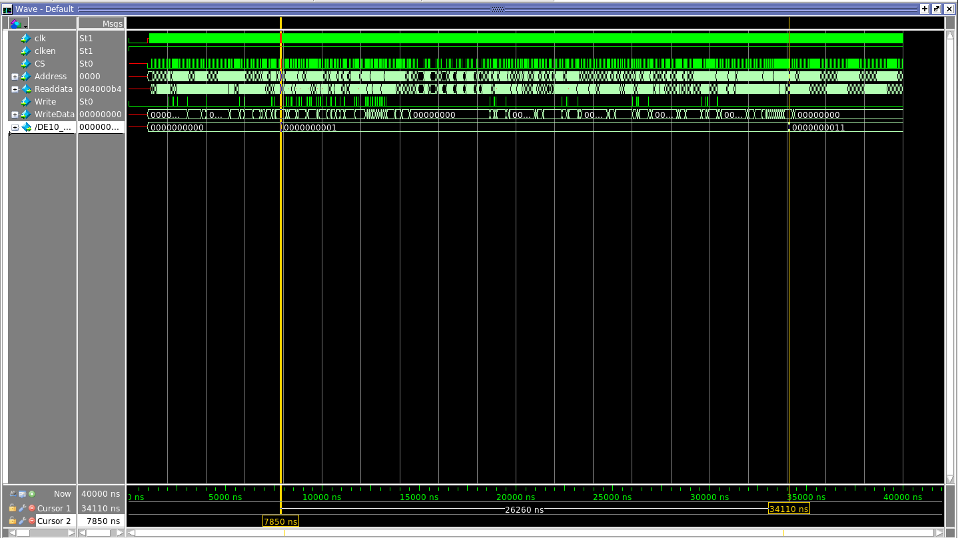
Figure 46: ModelSim Results for OnChip

If we compare this simulation to the previous one, the 19 lines of code this time take 1,313 clock cycles, (26.26 us), and if you include the setup it’s 1,701 clock cycles (34.11 us). That’s roughly 5.4X and 11.24X faster respectively when it comes to clock cycles! Do you see the performance vs size tradeoff?

Lastly in the ‘Assignments’ tab Device On the middle right of the screenDevice and Pin Options… Under the Configuration Category Configuration mode: Single Uncompressed Image with Memory Initialization Click OK through everything. This sets up the device to have memory initialization for on-chip, which we need for simulation purposes.

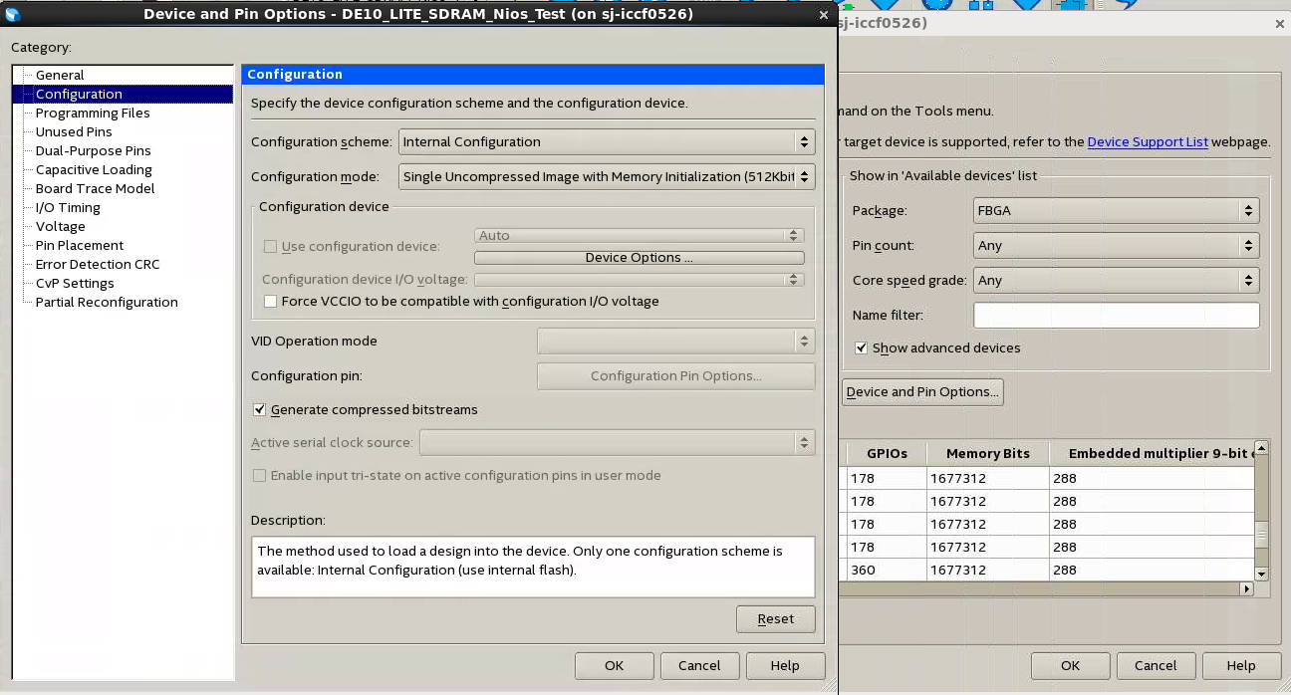
Figure 47: Programming Settings

