**How to reduce the percentage of crosstalk and SSN towards differential pins in Cyclone V devices**

**Introduction**

This document will describe how to reduce the percentage (%) of crosstalk and percentage (%) of SSN towards differential pins in the Quartus® II software when targeting Cyclone® V devices.

1. **Setup**

The guidelines in this document are applicable to Cyclone V devices and Quartus II software version 13.1 or later.

1. **How to reduce the % of crosstalk that affects differential pins**

When a design containing both differential and single ended (SE) I/O pins is compiled in the Quartus II software versions 13.1 or later, you may see a Critical Warning message such as the example shown below:

Critical Warning (12881): Too many 2.5-V SE IO in bank 8A with LVDS TX pin out_bus[0]. Reduce the number of 2.5-V I/Os used and re-run the analysis again. Please refer to the guideline from the Knowledge Base solution ID: rd10102013_979 and ensure the total % of crosstalk for the following SE I/O pins does not exceed 100%.

Info (12900): SE I/O out_bus[11] contributed to 263% of crosstalk

Info (12900): SE I/O out_bus[7] contributed to 20% of crosstalk

Info (12900): SE I/O out_bus[3] contributed to 71% of crosstalk

To reduce the % of crosstalk to a value within the safe threshold of < 100%, follow the steps below :

* Download the [*Cyclone V differential pad placement rule and pad mapping files* (.zip)](http://www.altera.com/literature/dp/cyclone-v/differential_pad_placement_mapping_files.zip)  and locate the pad mapping spreadsheet which matches the Cyclone V device you are targeting.
* Open up the spreadsheet and identify the violating SE I/O pins and the respective differential pin pair locations.
* Start with the violating SE I/O pin which contributes the most % of crosstalk. Reassign or move the violating SE I/O pin away from the differential pins as shown in Figure 2-1 below. It is recommended to move the violating SE I/O pin at least three to four pads away from the differential I/O pins.

For example:

The D6 and C6 pins are differential pins and D7 is the violating SE I/O pin. You can reassign the D7 SE I/O pin location to another location away from differential pin location. For example, move the D7 SE I/O pin location to G6.

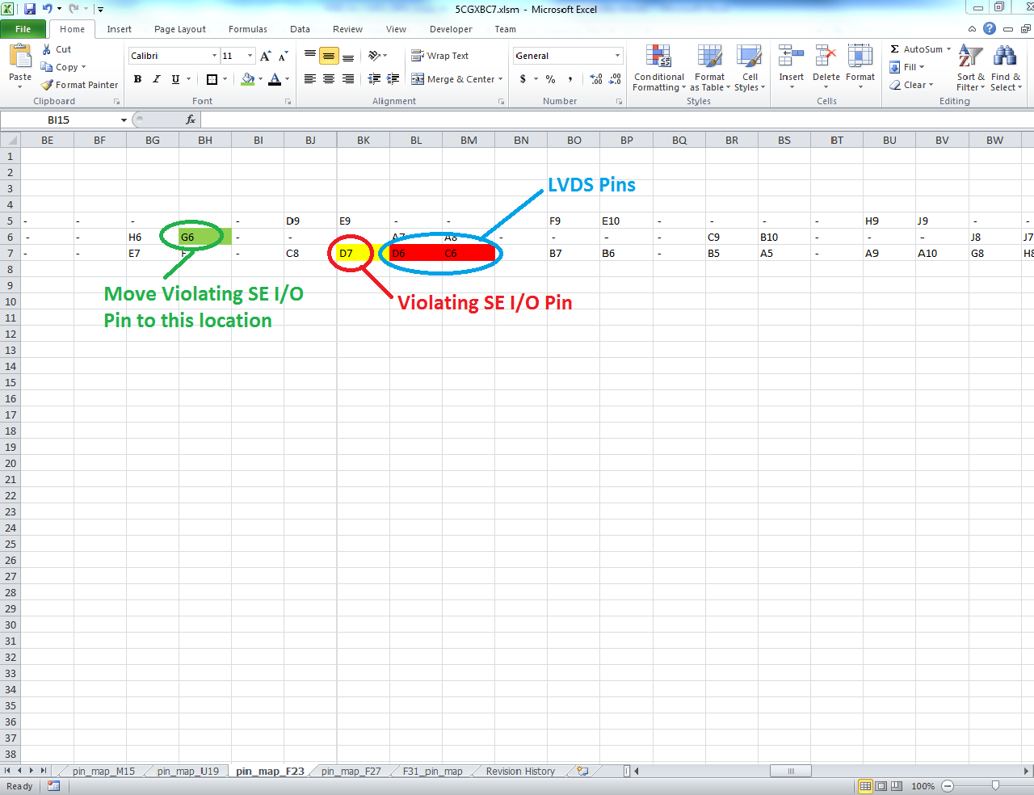

**Figure 2-1.** Example of relocating a single ended I/O to reduce % of crosstalk on a differential pin pair

* Recompile the design after reassigning or moving the violating SE I/O pins. You will get no further warnings if the summed % of the aggressors for a given victim is less than 100%.
* For further details of the physics based rules please refer to the [*Cyclone V Device Family Pin Connection Guidelines* (PDF)](http://www/literature/dp/cyclone-v/PCG-01014.pdf) (notes 11, 12, and 13).

1. **How to reduce the % of SSN towards differential pins**

When a design containing differential and single ended IO is compiled in Quartus II software versions 13.1 or later, you may see a Critical Warning message such as the example shown below:

Critical Warning (12887): Too many 2.5-V SE IO in bank 8A with LVDS RX pin in_bus[0]. Reduce the number of 2.5-V I/Os used and re-run the analysis again. Please refer to the guideline from the Knowledge Base solution ID: rd10102013_979 and ensure the total % of SSN for the following SE I/O pins does not exceed 100%.

Info (12899): SE I/O out_bus[12] contributed to 8% of the SSN

Info (12899): SE I/O out_bus[11] contributed to 8% of the SSN

Info (12899): SE I/O out_bus[10] contributed to 8% of the SSN

Info (12899): SE I/O out_bus[9] contributed to 8% of the SSN

Info (12899): SE I/O out_bus[8] contributed to 8% of the SSN

<TRUNCATED>

To reduce the % of SSN to a value within the safe threshold of < 100%, follow the steps below :

* Reduce the drive strength and slew rate of the violating SE I/O pins. Start with the violating SE I/O which contributes the most % of SSN.
* If you know that the SE I/O pins toggle rate are less than 100 MHz, you can use the IO_MAXIMUM_TOGGLE_RATE assignment (e.g. 99 MHz) on the violating SE I/O pins to make the physics based rules calculation less restrictive.
* Recompile the design after making the appropriate changes to the SE I/O pins. You will get no further warnings if the summed % of the aggressors for a given victim is less than 100%.

1. **Conclusion**

This document provides guidelines on how to reduce the % of crosstalk and % of SSN in designs that target Cyclone V devices and use a mixture of differential and single ended I/O, when using Quartus II software versions 13.1 or later.

1. **Revision History**

|  |  |  |
| --- | --- | --- |
| **Revision** | **Changes Made** | **Date** |
| V1.0 | Initial release. | Nov 2013 |

© 2013 Altera Corporation. All rights reserved. Altera, The Programmable Solutions Company, the stylized Altera logo, specific device designations, and all other words and logos that are identified as trademarks and/or service marks are, unless noted otherwise, the trademarks and service marks of Altera Corporation in the U.S. and other countries. All other product or service names are the property of their respective holders. Altera products are protected under numerous U.S. and foreign patents and pending applications, maskwork rights, and copyrights. Altera warrants performance of its semiconductor products to current specifications in accordance with Altera’s standard warranty, but reserves the right to make changes to any products and services at any time without notice. Altera assumes no responsibility or liability arising out of the application or use of any information, product, or service described herein except as expressly agreed to in writing by Altera. Altera customers are advised to obtain the latest version of device specifications before relying on any published information and before placing orders for products or services.